

**Capstone Project Report**

**Report 4 – Software Design Document**

– Ho Chi Minh, July 2021 –

**Table of Contents**

I. Project Report 3

1. Status Report 3

2. Team Involvements 3

3. Issues/Suggestions 3

II. Software Design Document 4

1. Overall Description 4

1.1 Assumptions 4

1.2 Design Constraints 4

1.3 [Technology Suggestion] 5

2. System Architecture Design 5

2.1 Overall Architecture 5

2.2 System Architecture 5

2.3 Package Diagram 5

3. System Detailed Design 6

3.1 <Feature Name1> 6

4. Data & Database Design 8

4.1 Database Design 8

4.2 Data File Design 9

# Software Design Description

## Overall Description

### 1.1. Assumptions

The system is designed based on the following assumptions:

* Windows 10
* Chrome 65
* SQL Server 2014
* End-user: Mumbi Staff and every user in Ho Chi Minh city

### 1.2. Design Constraints

The system should be compiled with the following items:

* End-user environment:
* Mumbi Staff in Windows 10 with Chrome browser version 65 or higher.
* Users: in Chrome browser version 65.
* Security requirement: prevent a user from cheating as much as possible.
* Network communication: this system depends on the network connection.

## 2. System Architecture Design

### 2.1. Overall Architecture

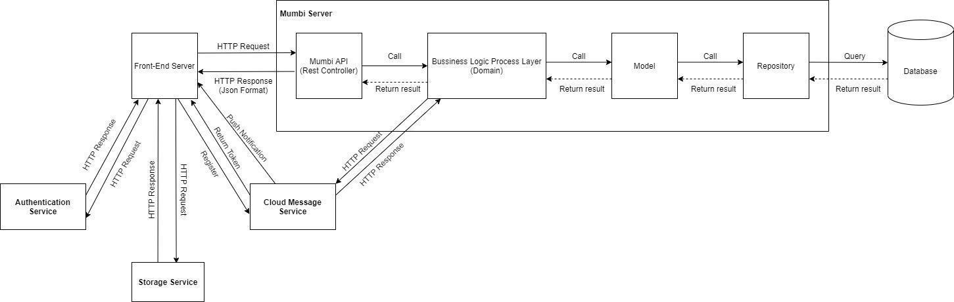

Figure 50 - System Overall Architecture Diagram

|  |  |  |
| --- | --- | --- |
| **No.** | **Name** | **Description** |
| **1** | Front-End Server | Client component to render and display data from the server. Client component provides functions:  - For staff: manage users, manage news, approve posts, manage guidebook, manage guidebook type, manage news type, manage pregnancy activity.  - For user: update phone number, receive vaccination schedule, follow development milestone |
| **2** | Storage Service | Storage service to store resources of users and staff. The resources such as images. |
| **3** | Cloud Message Service | Service to notify messages from the system to users. |
| **4** | Mumbi API | It handles requests from the Front End and responses from the system. |
| **5** | Business logic process layer (Domain) | It handles the business logic of the system. |
| **6** | Model | It supports the system to handle data. |
| **7** | Repository | It handles reading and writing data in the system. |
| **8** | Database | It stores the data of the system. |
| **9** | Authentication Service | This service is in charge of authenticating 3rd party  account of the staff and user and then send the result to our system. |

Table 55 - Architecture Diagram Dictionary

### 2.2. Package Diagram

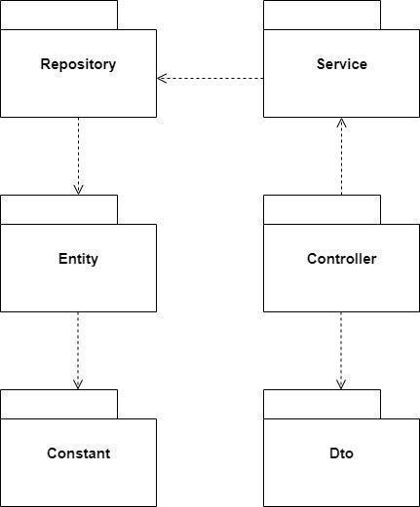

Figure 51 - Package Diagram

|  |  |  |
| --- | --- | --- |
| **No.** | **Name** | **Description** |
| **1** | Repository | For database calls. It keeps the interface classes that implement code to access the data layer. |
| **2** | Service | For business logic. It keeps the interface of service classes and implementation of it. |
| **3** | Entity | For mapping with database tables. |
| **4** | Constant | For constant variables. |
| **5** | Controller | For the request mapping. |
| **6** | Dto | For data transfer. |

Table 56 - Component Diagram Dictionary

## 3. System Detailed Design

### 3.1. Class Diagram

### 3.1.1 Class Diagram

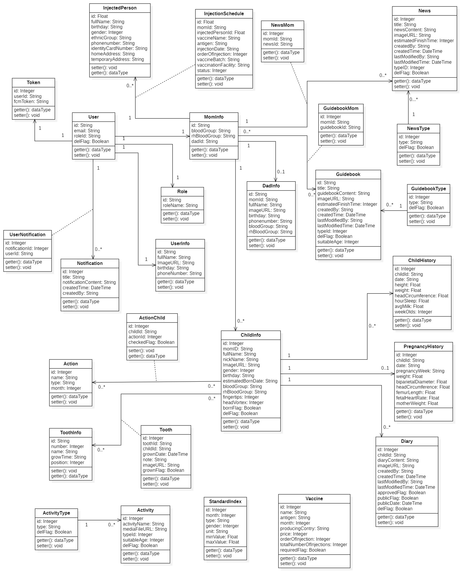

Figure 52 - Class Diagram

### 3.1.2. Class Specifications

**UserInfo**

|  |  |  |  |  |
| --- | --- | --- | --- | --- |
| **No.** | **Attribute** | **Data Type** | **Visibility** | **Description** |
| **1** | id | Int | Private | Unique identifier of user |
| **2** | fullName | String | Private | The full name of user |
| **3** | imageURL | DateTime | Private | The image of user |
| **4** | birthday | String | Private | The birthday of user |
| **5** | phoneNumber | Boolean | Private | The phone number of user |

Table 57 - <Class Specification> User

**MomInfo**

|  |  |  |  |  |
| --- | --- | --- | --- | --- |
| **No.** | **Attribute** | **Data Type** | **Visibility** | **Description** |
| **1** | id | String | Private | Unique identifier of mom |
| **2** | bloodGroup | String | Private | The blood group of mom |
| **3** | rhBloodGroup | String | Private | The rh blood group of mom |
| **4** | dadId | String | Private | Unique identifier of dad |

Table 58 - <Class Specification> MomInfo

**DadInfo**

|  |  |  |  |  |
| --- | --- | --- | --- | --- |
| **No.** | **Attribute** | **Data Type** | **Visibility** | **Description** |
| **1** | id | String | Private | Unique identifier of dad |
| **2** | momId | String | Private | Unique identifier of mom |
| **3** | phoneNumber | String | Private | The phone number of a father |
| **4** | bloodGroup | String | Private | The blood group of a father |
| **5** | rhBloodGroup | String | Private | The rh blood group of a father |
| **6** | birthday | String | Private | The birthday of a father |
| **7** | fullName | String | Private | The full name of a dad |
| **8** | imageURL | String | Private | The image of a dad |

Table 59 - <Class Specification> DadInfo

**News**

|  |  |  |  |  |
| --- | --- | --- | --- | --- |
| **No.** | **Attribute** | **Data Type** | **Visibility** | **Description** |
| **1** | idd | Int | Private | Unique identifier of a news |
| **2** | title | String | Private | The title of a news |
| **3** | imageURL | String | Private | The image of a news |
| **4** | newsContent | String | Private | The news content of a news |
| **5** | typeID | Integer | Private | Unique identifier of type |
| **6** | estimatedFinishTime | Integer | Private | The estimated finish time of a news |
| **7** | createdBy | String | Private | The estimated finish time of a news |
| **8** | createdTime | DateTime | Private | The estimated finish time of a news |
| **9** | lastModifiedBy | String | Private | The user last modified of a news |
| **10** | lastModifiedTime | DateTime | Private | The last modified time of a news |
| **11** | delFlag | Boolean | Private | The status delete of news |

Table 60 - <Class Specification> News

**Token**

|  |  |  |  |  |
| --- | --- | --- | --- | --- |
| **No.** | **Attribute** | **Data Type** | **Visibility** | **Description** |
| **1** | id | Integer | Private | Unique identifier of token |
| **2** | userId | String | Private | Unique identifier of a User |
| **3** | fcmToken | String | Private | The fcm token of a token |

Table 61 - <Class Specification> Token

**Injection Schedule**

|  |  |  |  |  |
| --- | --- | --- | --- | --- |
| **No.** | **Attribute** | **Data Type** | **Visibility** | **Description** |
| **1** | id | Integer | Private | Unique identifier of a Injection Schedule |
| **2** | momId | String | Private | Unique identifier of a mom |
| **3** | injectedPersonId | String | Private | Unique identifier of a injected person |
| **4** | vaccineName | String | Private | The vaccine name of a vaccine in injection schedule |
| **5** | antigen | String | Private | The antigen of a vaccine in injection schedule |
| **6** | injectionDate | String | Private | The injection date of a vaccine in injection schedule |
| **7** | orderOfInjection | String | Private | The order of injection of a vaccine in injection schedule |
| **8** | vaccineBatch | String | Private | The vaccine batch of a vaccine in injection schedule |
| **9** | vaccineFacility | String | Private | The vaccine facility of a vaccine in injection schedule |
| **10** | status | String | Private | The status of a vaccine in injection schedule |

Table 62 - <Class Specification> Injection Schedule

**Tooth**

|  |  |  |  |  |
| --- | --- | --- | --- | --- |
| **No.** | **Attribute** | **Data Type** | **Visibility** | **Description** |
| **1** | id | Integer | Private | Unique identifier of tooth |
| **2** | toothId | String | Private | Unique identifier of tooth |
| **3** | childId | String | Private | Unique identifier of child |
| **4** | grownDate | DateTime | Private | The grown date of tooth |
| **5** | note | String | Private | The note of tooth |
| **6** | imageURL | String | Private | The image of tooth |
| **7** | grownFlag | Boolean | Private | The status grown of tooth |

Table 63 - <Class Specification> Tooth

**NewsType**

|  |  |  |  |  |
| --- | --- | --- | --- | --- |
| **No.** | **Attribute** | **Data Type** | **Visibility** | **Description** |
| **1** | id | Integer | Private | Unique identifier of a news type |
| **2** | type | String | Private | The type of a news type |
| **3** | delFlag | Boolean | Private | The status delete of a news type |

Table 64 - <Class Specification> NewsType

**Role**

|  |  |  |  |  |
| --- | --- | --- | --- | --- |
| **No.** | **Attribute** | **Data Type** | **Visibility** | **Description** |
| **1** | id | String | Private | Unique identifier of a role |
| **2** | roleName | String | Private | The name of a role |

Table 65 - <Class Specification> Role

**ChildInfo**

|  |  |  |  |  |
| --- | --- | --- | --- | --- |
| **No.** | **Attribute** | **Data Type** | **Visibility** | **Description** |
| **1** | gender | Integer | Private | The gender of a child |
| **2** | fingertips | String | Private | The fingertips of a child |
| **3** | headVortex | Float | Private | The head vortex of a child |
| **4** | bloodGroup | String | Private | The blood group of a child |
| **5** | rhBloodGroup | String | Private | The rh blood group of a child |
| **6** | fullName | String | Private | The full name of a child |
| **7** | nickName | String | Private | The nickname of a child |
| **8** | imageURL | String | Private | The image of a child |
| **9** | birthday | DateTime | Private | The birthday of a child |
| **10** | id | Integer | Private | Unique identifier of a child |
| **11** | momID | String | Private | Unique identifier of a mom |
| **12** | estimatedBornDate | String | Private | The estimated born date of a child |
| **13** | bornFlag | Boolean | Private | The status born of child |
| **14** | delFlag | Boolean | Private | The status delete of child |

Table 66 - <Class Specification> ChildInfo

**Diary**

|  |  |  |  |  |
| --- | --- | --- | --- | --- |
| **No.** | **Attribute** | **Data Type** | **Visibility** | **Description** |
| **1** | id | Integer | Private | Unique identifier of a diary |
| **2** | diaryContent | String | Private | The content of a diary |
| **3** | imageURL | String | Private | The image of a diary |
| **4** | approvedFlag | Boolean | Private | The status approved of diary |
| **5** | childId | String | Private | Unique identifier of a child |
| **6** | publicFlag | Boolean | Private | The status public of diary |
| **7** | createdBy | String | Private | The estimated finish time of a diary |
| **8** | createdTime | DateTime | Private | The estimated finish time of a diary |
| **9** | lastModifiedBy | String | Private | The user last modified of a diary |
| **10** | lastModifiedTime | DateTime | Private | The last modified time of a diary |
| **11** | delFlag | Boolean | Private | The status delete of diary |
| **12** | publicDate | DateTime | Private | The public date of diary |

Table 67 - <Class Specification> Diary

**PregnancyHistory**

|  |  |  |  |  |
| --- | --- | --- | --- | --- |
| **No.** | **Attribute** | **Data Type** | **Visibility** | **Description** |
| **1** | id | Integer | Private | Unique identifier of a pregnancy history |
| **2** | childId | String | Private | Unique identifier of a child |
| **3** | headCircumference | Float | Private | The head circumference of a pregnancy in pregnancy history |
| **4** | femurLength | Float | Private | The femur length of a pregnancy in pregnancy history |
| **5** | fetalHeartRate | String | Private | The fetal heart rate of a pregnancy in pregnancy history |
| **6** | pregnancyWeek | String | Private | The week of a pregnancy in pregnancy history |
| **7** | weight | Float | Private | The weight of a pregnancy in pregnancy history |
| **8** | pregnancyType | Float | Private | The type a pregnancy |
| **9** | date | String | Private | The date of a pregnancy in pregnancy history |
| **10** | biparietalDiameter | Float | Private | The biparietal diameter of a pregnancy in pregnancy history |
| **11** | motherWeight | Float | Private | The mother weight of a pregnancy in pregnancy history |

Table 68 - <Class Specification> PregnancyHistory

**Activity**

|  |  |  |  |  |
| --- | --- | --- | --- | --- |
| **No.** | **Attribute** | **Data Type** | **Visibility** | **Description** |
| **1** | id | Integer | Private | Unique identifier of a activity |
| **2** | activityName | String | Private | Unique identifier of a child |
| **3** | mediaFileURL | String | Private | The media file of a activity |
| **4** | suitableAge | Integer | Private | The suitable age of a activity |
| **5** | typeId | String | Private | Unique identifier of a type |
| **6** | delFlag | Boolean | Private | The status delete of activity |

Table 69 - <Class Specification> Activity

**Vaccine**

|  |  |  |  |  |
| --- | --- | --- | --- | --- |
| **No.** | **Attribute** | **Data Type** | **Visibility** | **Description** |
| **1** | id | Int | Private | Unique identifier of a vaccine |
| **2** | name | String | Private | The name of a vaccine |
| **3** | totalNumberOfInjections | Integer | Private | The total number of injections of a vaccine |
| **4** | price | Float | Private | The price of a vaccine |
| **5** | producingCountry | String | Private | The producing country of a vaccine |
| **6** | antigen | String | Private | The antigen of a vaccine |
| **7** | month | Integer | Private | The month of a vaccine |
| **8** | requiredFlag | Boolean | Private | The status required of a vaccine |
| **9** | orderOfInjection | Integer | Private | The order of injection of a vaccine |

Table 70 - <Class Specification> Vaccine

**ChildHistory**

|  |  |  |  |  |
| --- | --- | --- | --- | --- |
| **No.** | **Attribute** | **Data Type** | **Visibility** | **Description** |
| **1** | id | Integer | Private | Unique identifier of a child history |
| **2** | childId | String | Private | Unique identifier of a child |
| **3** | headCircumference | Float | Private | The head circumference of a child in child history |
| **4** | hourSleep | Float | Private | The hour sleep of a child in child history |
| **5** | avgMilk | Float | Private | The average milk of a child in child history |
| **6** | weekOlds | Integer | Private | The week old of a child in child history |
| **7** | weight | Float | Private | The weight of a child in child history |
| **8** | date | String | Private | The date of a pregnancy in pregnancy history |
| **9** | height | Float | Private | The height of a child in child history |

Table 71 - <Class Specification> Vaccine History

**GuidebookType**

|  |  |  |  |  |
| --- | --- | --- | --- | --- |
| **No.** | **Attribute** | **Data Type** | **Visibility** | **Description** |
| **1** | id | Integer | Private | Unique identifier of a guidebook type |
| **2** | type | String | Private | The type of a guidebook type |
| **3** | delFlag | Boolean | Private | The status delete of a guidebook type |

Table 72 - <Class Specification> GuidebookType

**ActivityType**

|  |  |  |  |  |
| --- | --- | --- | --- | --- |
| **No.** | **Attribute** | **Data Type** | **Visibility** | **Description** |
| **1** | id | Integer | Private | Unique identifier of a activity type |
| **2** | type | String | Private | The type of a activity type |
| **3** | delFlag | Boolean | Private | The status delete of a activity type |

Table 73 - <Class Specification> ActivityType

**GuidebookMom**

|  |  |  |  |  |
| --- | --- | --- | --- | --- |
| **No.** | **Attribute** | **Data Type** | **Visibility** | **Description** |
| **1** | id | Integer | Private | Unique identifier of a guidebook mom |
| **2** | momId | String | Private | Unique identifier of a mom |
| **3** | guidebookId | String | Private | Unique identifier of a guidebook |

Table 74 - <Class Specification> GuidebookMom

**NewsMom**

|  |  |  |  |  |
| --- | --- | --- | --- | --- |
| **No.** | **Attribute** | **Data Type** | **Visibility** | **Description** |
| **1** | id | Integer | Private | Unique identifier of a news mom |
| **2** | momId | String | Private | Unique identifier of a mom |
| **3** | newsId | String | Private | Unique identifier of a news |

Table 75 - <Class Specification> NewsMom

**Guidebook**

|  |  |  |  |  |
| --- | --- | --- | --- | --- |
| **No.** | **Attribute** | **Data Type** | **Visibility** | **Description** |
| **1** | id | Integer | Private | Unique identifier of a guidebook |
| **2** | title | String | Private | The title of a guidebook |
| **3** | imageURL | String | Private | The image of a guidebook |
| **4** | guidebookContent | String | Private | The news content of a guidebook |
| **5** | typeID | Integer | Private | Unique identifier of type |
| **6** | estimatedFinishTime | Integer | Private | The estimated finish time of a guidebook |
| **7** | createdBy | String | Private | The estimated finish time of a guidebook |
| **8** | createdTime | DateTime | Private | The estimated finish time of a guidebook |
| **9** | lastModifiedBy | String | Private | The user last modified of a guidebook |
| **10** | lastModifiedTime | DateTime | Private | The last modified time of a guidebook |
| **11** | delFlag | Boolean | Private | The status delete of guidebook |
| **12** | suitableAge | Integer | Private | The suitable age of a guidebook |

Table 76 - <Class Specification> Guidebook

**User**

|  |  |  |  |  |
| --- | --- | --- | --- | --- |
| **No.** | **Attribute** | **Data Type** | **Visibility** | **Description** |
| **1** | id | Integer | Private | Unique identifier of user |
| **2** | email | String | Private | The email of user |
| **3** | roleId | DateTime | Private | Unique identifier of role |
| **4** | delFlag | Boolean | Private | The status delete of user |

Table 77 - <Class Specification> User

**UserNotification**

|  |  |  |  |  |
| --- | --- | --- | --- | --- |
| **No.** | **Attribute** | **Data Type** | **Visibility** | **Description** |
| **1** | id | Integer | Private | Unique identifier of user notification |
| **2** | notificationId | Integer | Private | Unique identifier of notification |
| **3** | userId | String | Private | Unique identifier of user |

Table 78 - <Class Specification> UserNotification

**Notification**

|  |  |  |  |  |
| --- | --- | --- | --- | --- |
| **No.** | **Attribute** | **Data Type** | **Visibility** | **Description** |
| **1** | id | Integer | Private | Unique identifier of notification |
| **2** | title | String | Private | The title of notification |
| **3** | notificationContent | String | Private | The notification content of notification |
| **4** | createdBy | String | Private | The estimated finish time of a notification |
| **5** | createdTime | DateTime | Private | The estimated finish time of a notification |

Table 79 - <Class Specification> Notification

**InjectedPerson**

|  |  |  |  |  |
| --- | --- | --- | --- | --- |
| **No.** | **Attribute** | **Data Type** | **Visibility** | **Description** |
| **1** | id | Float | Private | Unique identifier of injected person |
| **2** | gender | Integer | Private | The gender of a person in injected person |
| **3** | phonenumber | String | Private | The phone number of a person in injected person |
| **4** | ethnicGroup | String | Private | The ethnic group of a person in injected person |
| **5** | identityCardNumber | String | Private | The identity card number of a person in injected person |
| **6** | birthday | String | Private | The birthday of a person in injected person |
| **7** | fullName | String | Private | The fullname of a person in injected person |
| **8** | homeAddress | String | Private | The home address of a person in injected person |
| **9** | temporaryAddress | String | Private | The temporary address of a person in injected person |

Table 80 - <Class Specification> InjectedPerson

**StandardIndex**

|  |  |  |  |  |
| --- | --- | --- | --- | --- |
| **No.** | **Attribute** | **Data Type** | **Visibility** | **Description** |
| **1** | id | Integer | Private | Unique identifier of standard index |
| **2** | month | Integer | Private | The month of standard index |
| **3** | type | String | Private | The type of standard index |
| **4** | gender | Integer | Private | The gender of standard index |
| **5** | unit | String | Private | The unit of standard index |
| **6** | minValue | Float | Private | The min value of standard index |
| **7** | maxValue | Float | Private | The max value of standard index |

Table 81 - <Class Specification> InjectedPerson

**Action**

|  |  |  |  |  |
| --- | --- | --- | --- | --- |
| **No.** | **Attribute** | **Data Type** | **Visibility** | **Description** |
| **1** | id | Integer | Private | Unique identifier of action |
| **2** | month | Integer | Private | The month of action |
| **3** | type | String | Private | The type of action |
| **4** | name | String | Private | The name of action |

Table 82 - <Class Specification> Action

**ActionChild**

|  |  |  |  |  |
| --- | --- | --- | --- | --- |
| **No.** | **Attribute** | **Data Type** | **Visibility** | **Description** |
| **1** | id | String | Private | Unique identifier of action child |
| **2** | childId | String | Private | Unique identifier of child |
| **3** | actionId | String | Private | Unique identifier of action |
| **4** | checkedFlag | Boolean | Private | The status checked of action child |

Table 83 - <Class Specification> ActionChild

**ToothInfo**

|  |  |  |  |  |
| --- | --- | --- | --- | --- |
| **No.** | **Attribute** | **Data Type** | **Visibility** | **Description** |
| **1** | id | String | Private | Unique identifier of tooth info |
| **2** | number | Integer | Private | The number of tooth info |
| **3** | growTime | String | Private | The grow time of tooth info |
| **4** | name | String | Private | The name of tooth info |
| **5** | position | Integer | Private | The position of tooth info |

Table 84 - <Class Specification> ToothInfo

### 3.2. Sequence Diagram

#### 3.2.1. Login

***Summary:*** *This diagram shows the process for the actor login into the system*

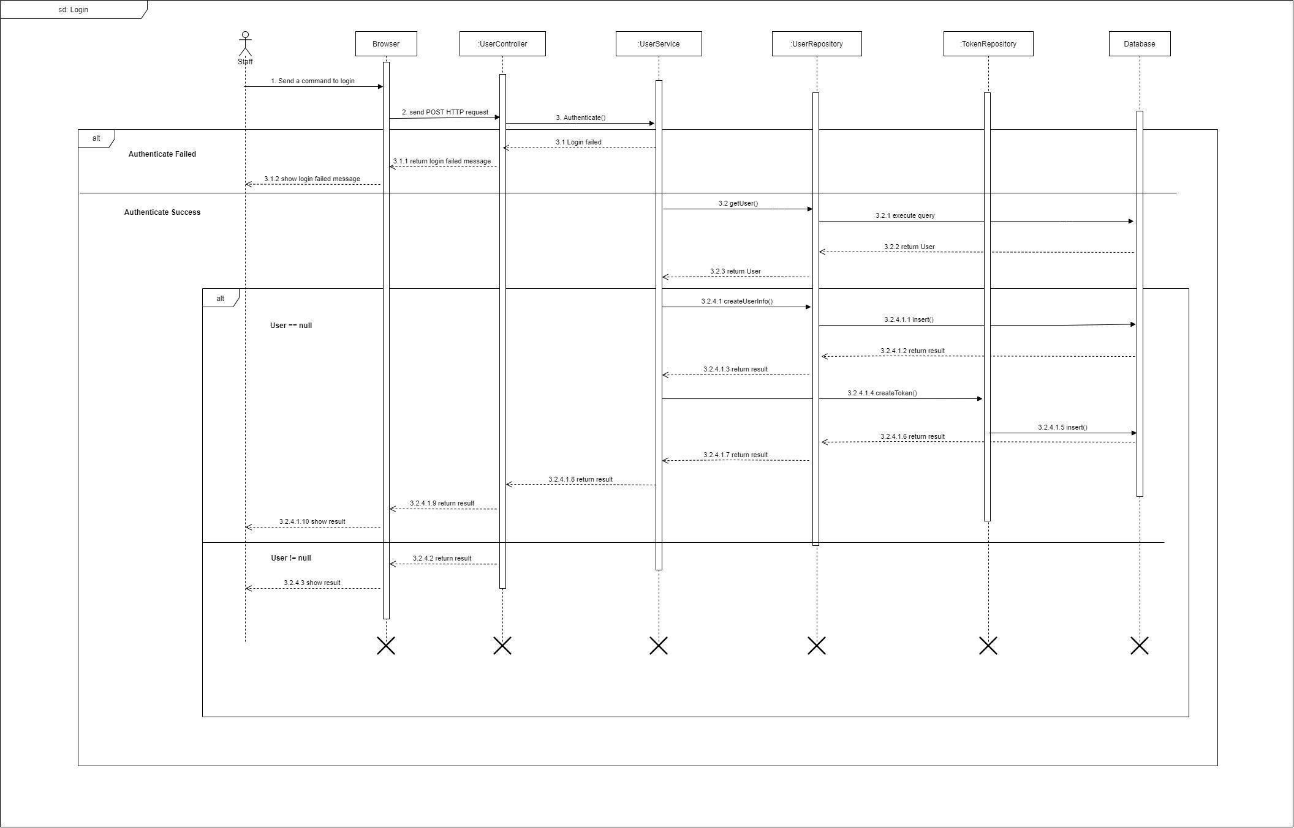

Figure 53 - <Sequence Diagram> Login

#### 3.2.2. Get all news

***Summary:*** *This diagram shows the process for the actor to get all News.*

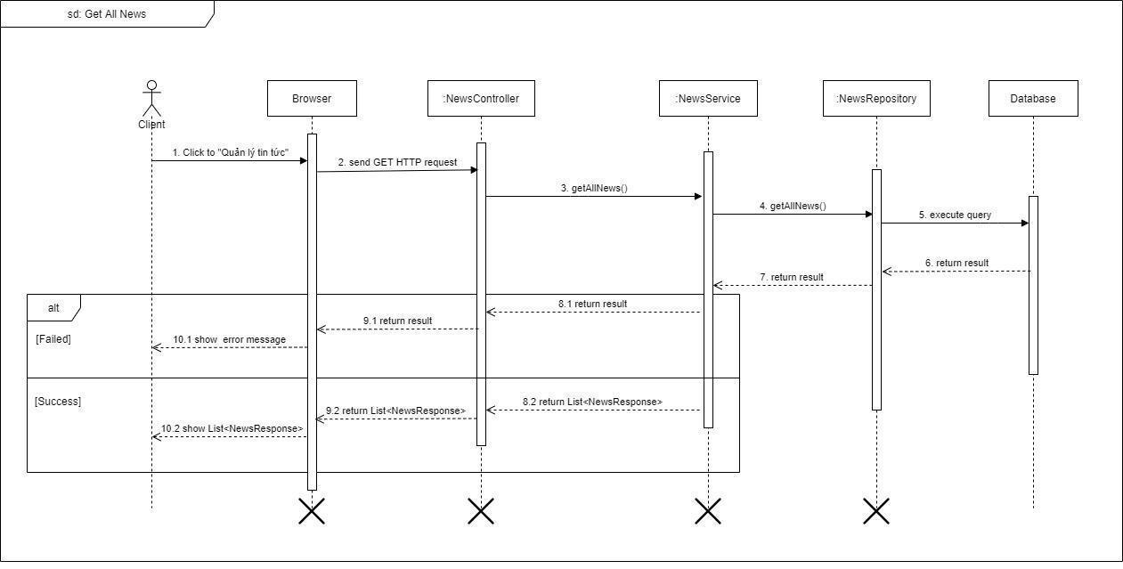

Figure 54 - <Sequence Diagram> Get all News

#### 3.2.3. Create news

***Summary:*** *This diagram shows the process for the actor to create news.*

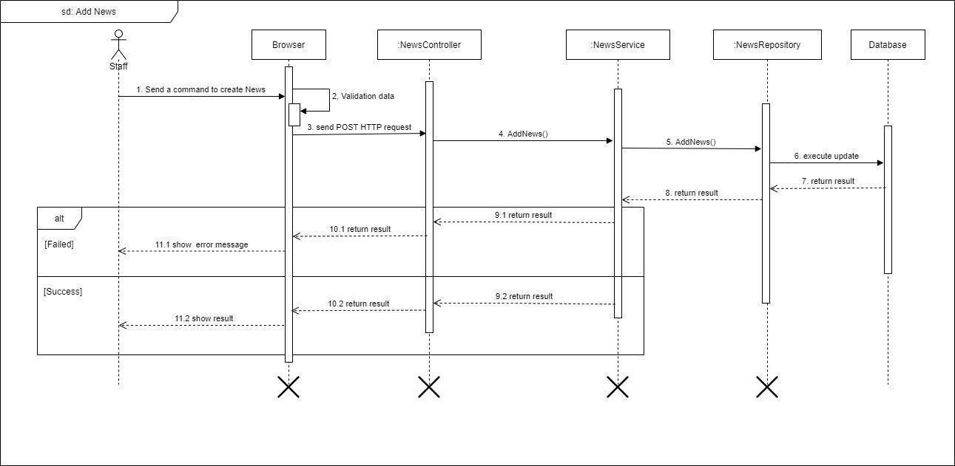Figure 55 - <Sequence Diagram> Create News

#### 3.2.4. Update news

***Summary:*** *This diagram shows the process for the actor to update news.*

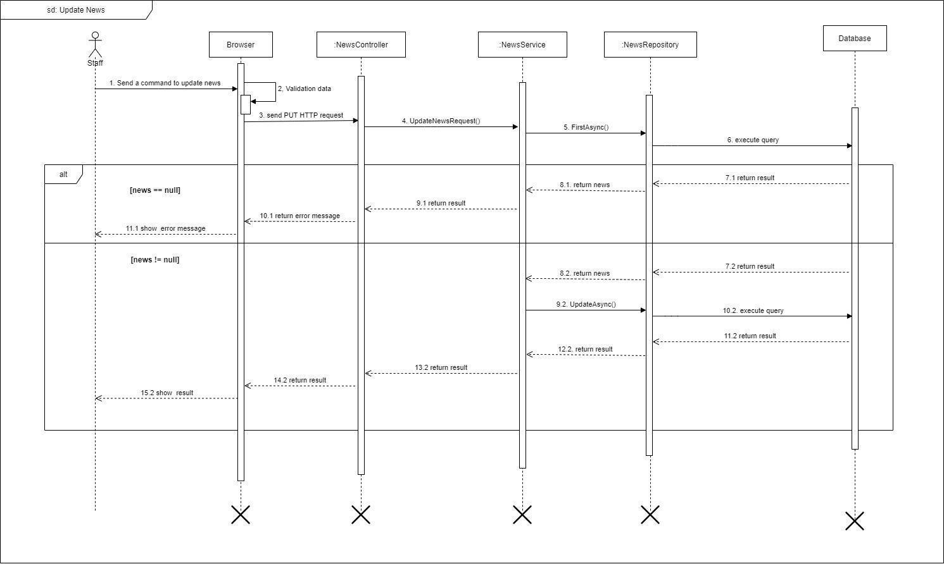

Figure 56 - <Sequence Diagram> Update news

#### 3.2.5. Delete news

***Summary:*** *This diagram shows the process for the actor to delete news.*

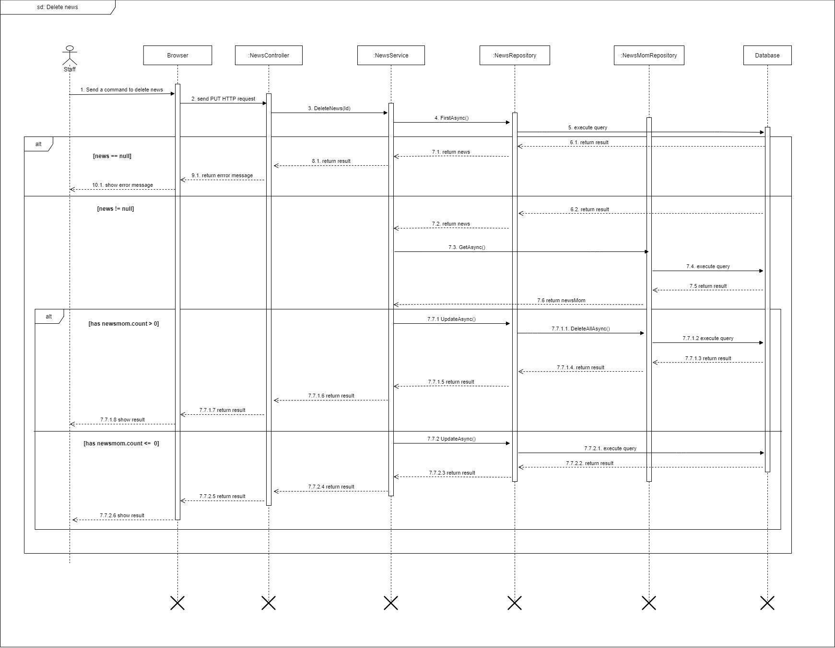

Figure 57 - <Sequence Diagram> Delete news

#### 3.2.6. Get all user info

***Summary:*** *This diagram shows the process for the actor get all user information.*

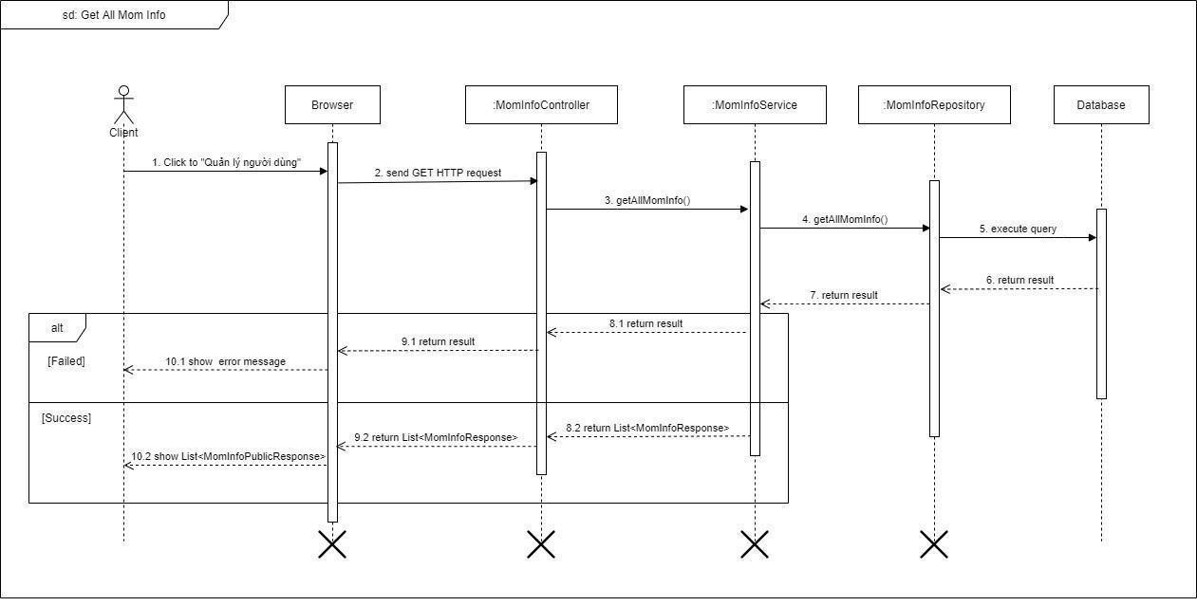

Figure 58 - <Sequence Diagram> Get all user info

#### 3.2.7. Delete user

***Summary:*** *This diagram shows the process for the actor delete user.*

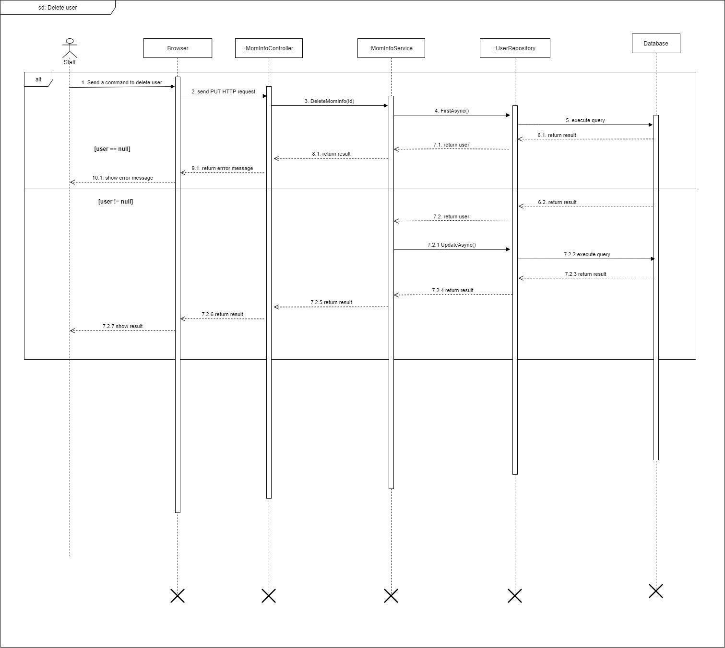

Figure 59 - <Sequence Diagram> Delete user

#### 3.2.8. Create guidebook

***Summary:*** *This diagram shows the process for the actor create guidebook.*

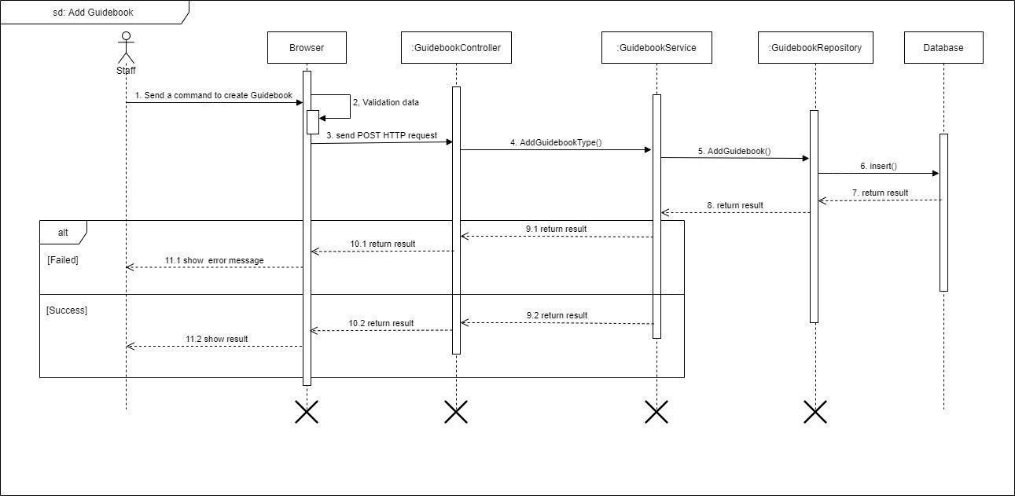

Figure 60 - <Sequence Diagram> Create guidebook

#### 3.2.9. Update guidebook

***Summary:*** *This diagram shows the process for the actor update guidebook.*

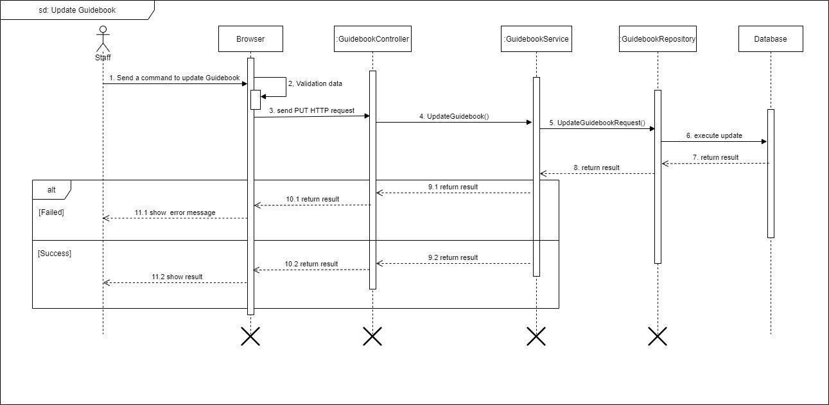

Figure 61 - <Sequence Diagram> Update guidebook

#### 3.2.10. Delete guidebook

***Summary:*** *This diagram shows the process for the actor delete guidebook.*

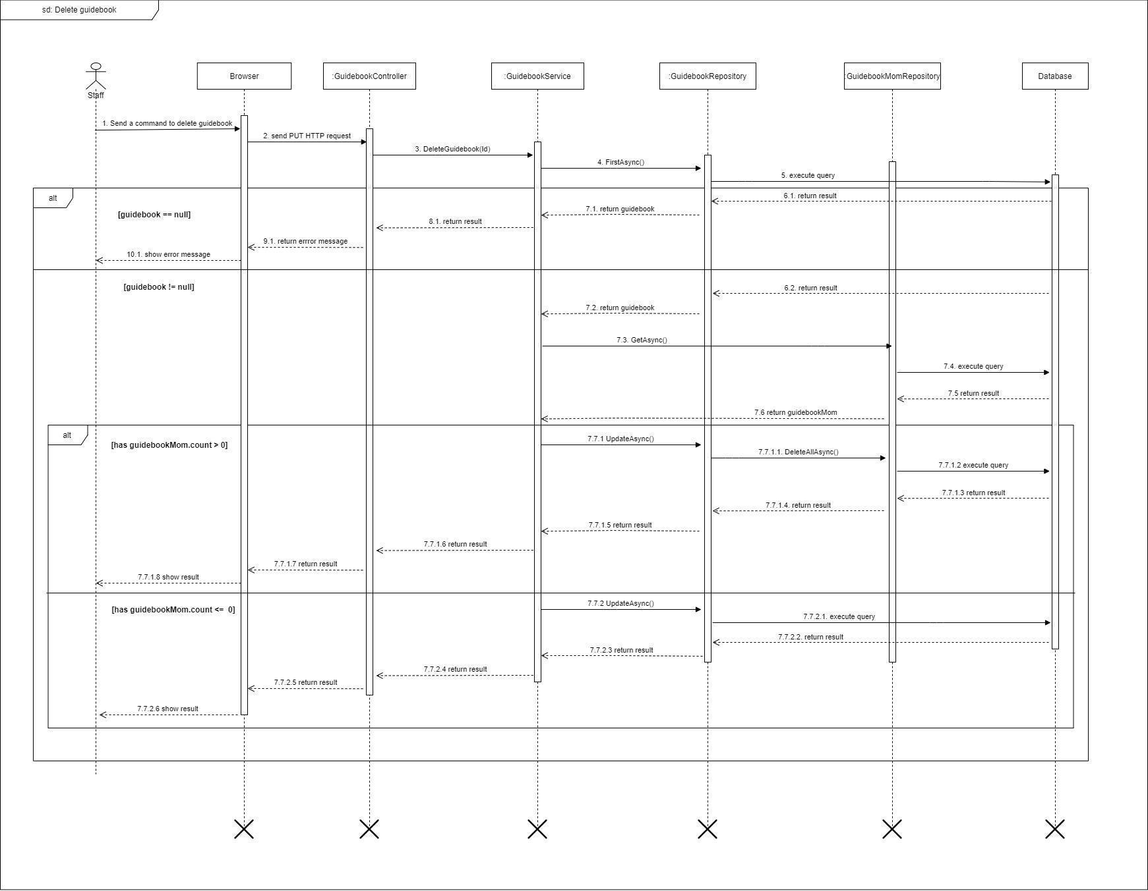

Figure 62 - <Sequence Diagram> Delete guidebook

#### 3.2.11. Create guidebook type

***Summary:*** *This diagram shows the process for the actor to create a guidebook type.*

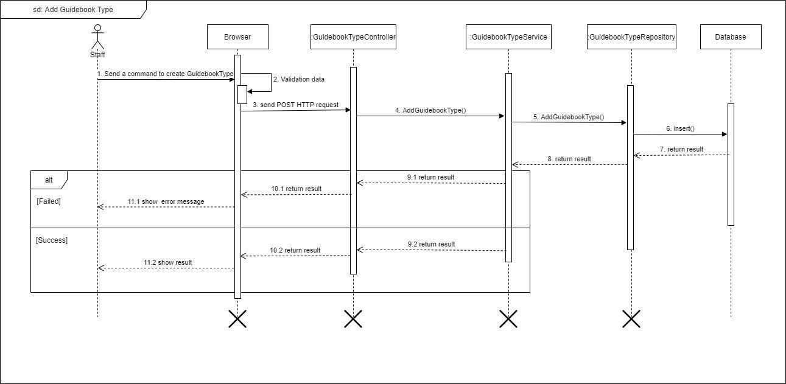

Figure 63 - <Sequence Diagram> Create guidebook type

#### 3.2.12. Update guidebook type

***Summary:*** *This diagram shows the process for the actor update guidebook type.*

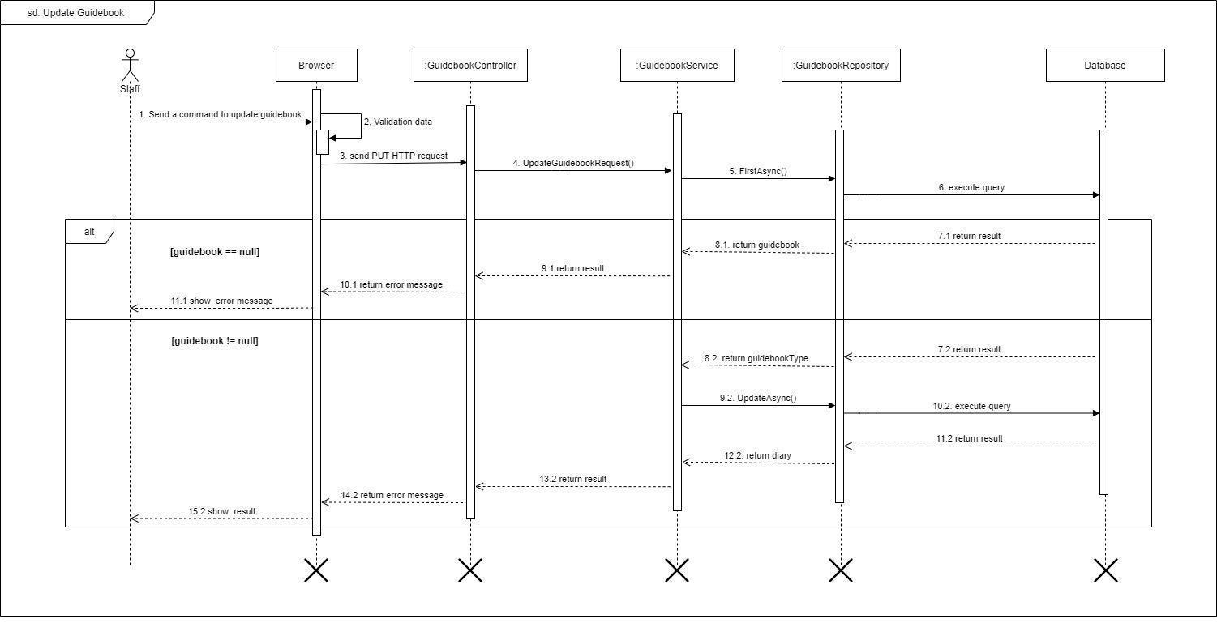

Figure 64 - <Sequence Diagram> Update guidebook type

#### 3.2.13. Delete guidebook type

***Summary:*** *This diagram shows the process for the actor delete guidebook type.*

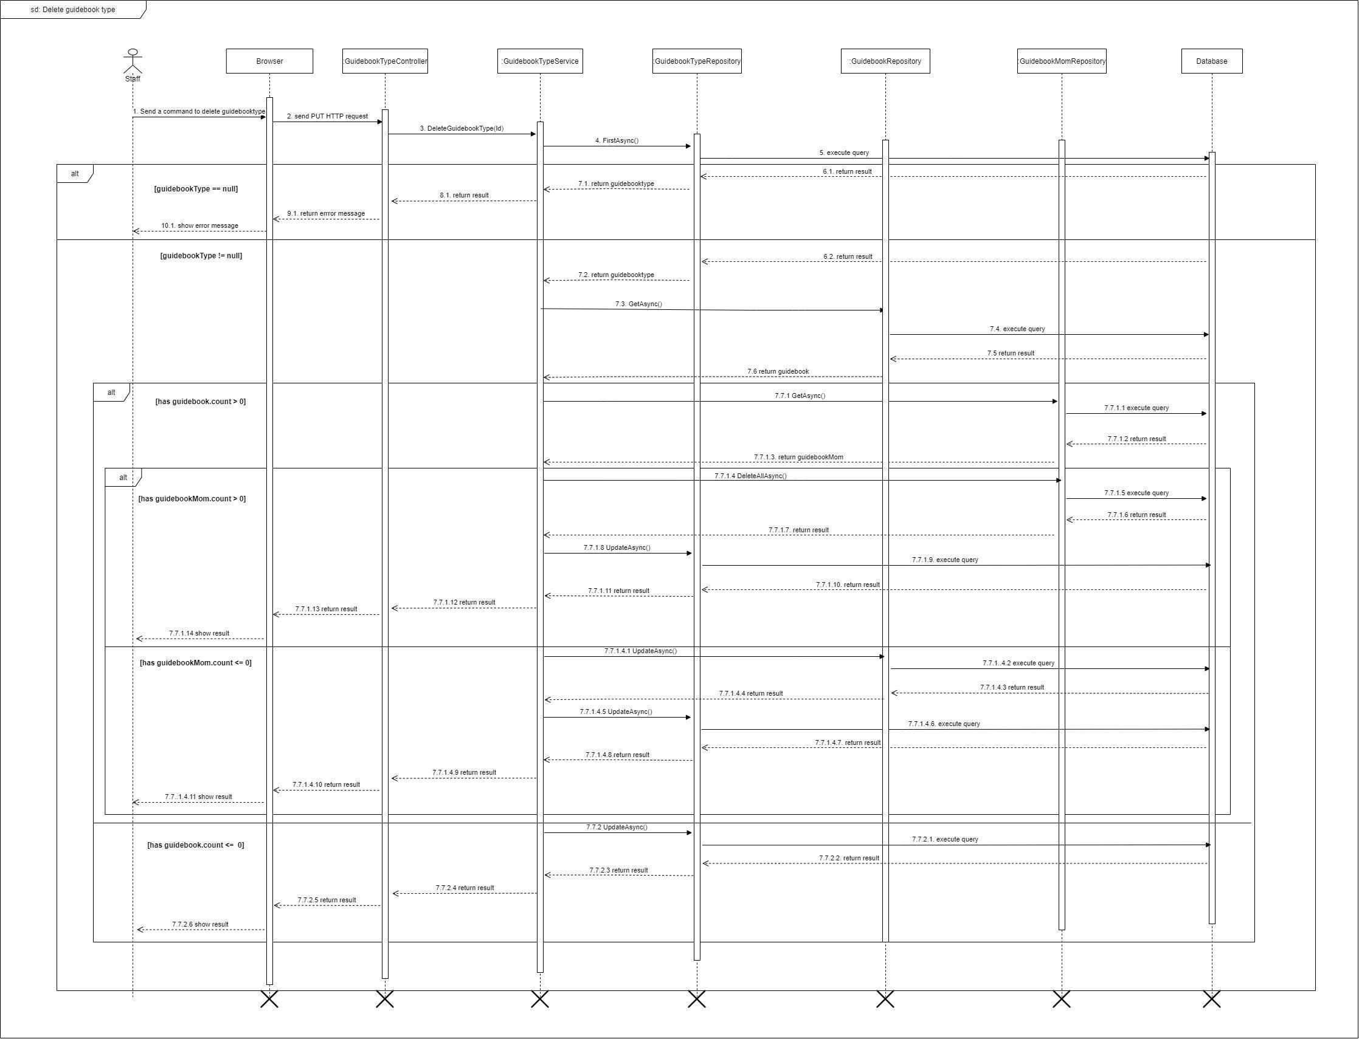

Figure 65 - <Sequence Diagram> Delete guidebook type

#### 3.2.14. Create news type

***Summary:*** *This diagram shows the process for the actor to create news type.*

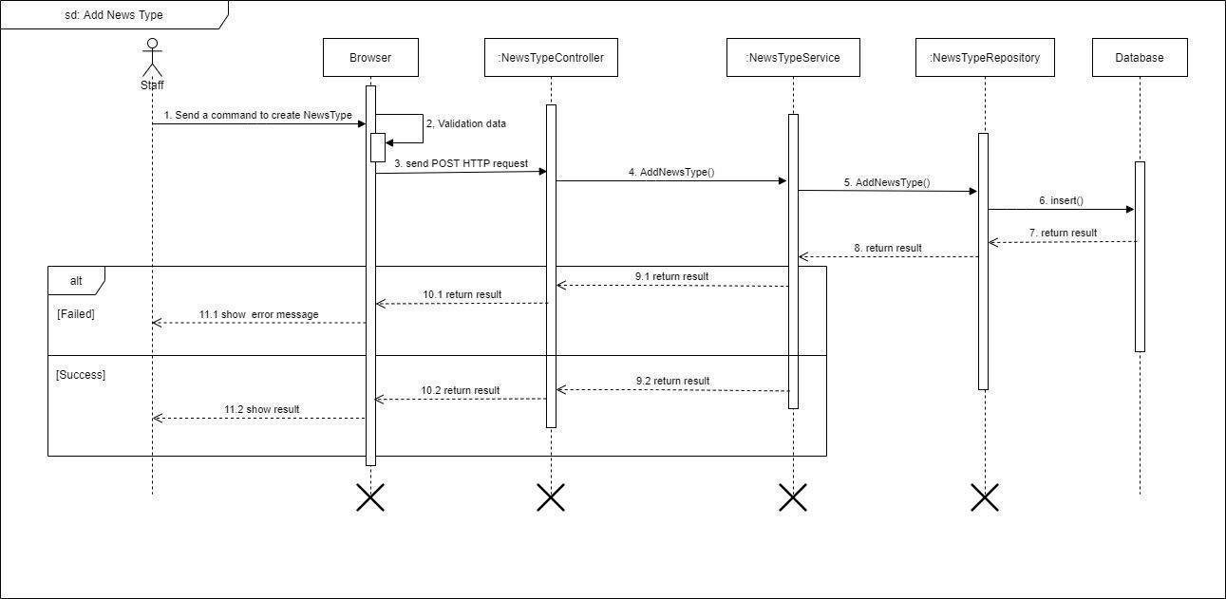

Figure 66 - <Sequence Diagram> Create news type

#### 3.2.15. Update news type

***Summary:*** *This diagram shows the process for the actor update news type.*

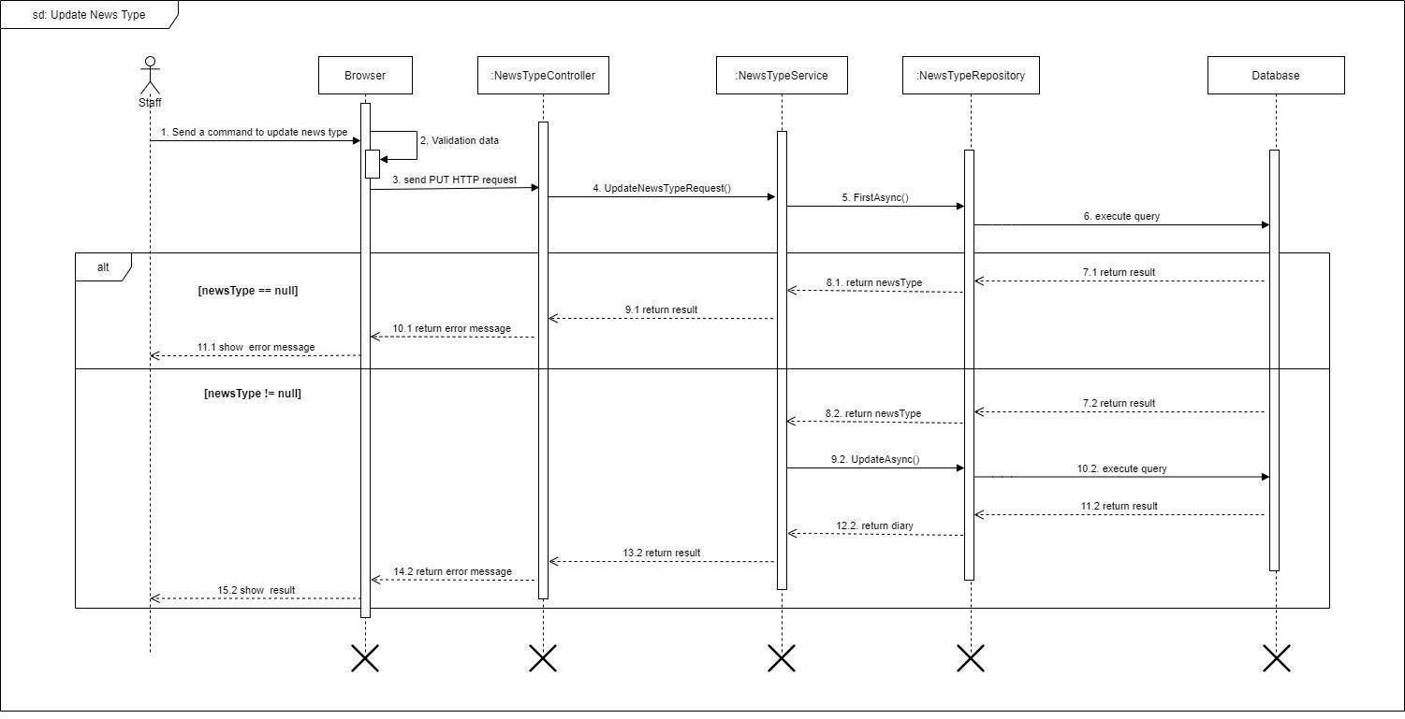

Figure 67 - <Sequence Diagram> Update news type

#### 3.2.16. Delete news type

***Summary:*** *This diagram shows the process for the actor to delete news type.*

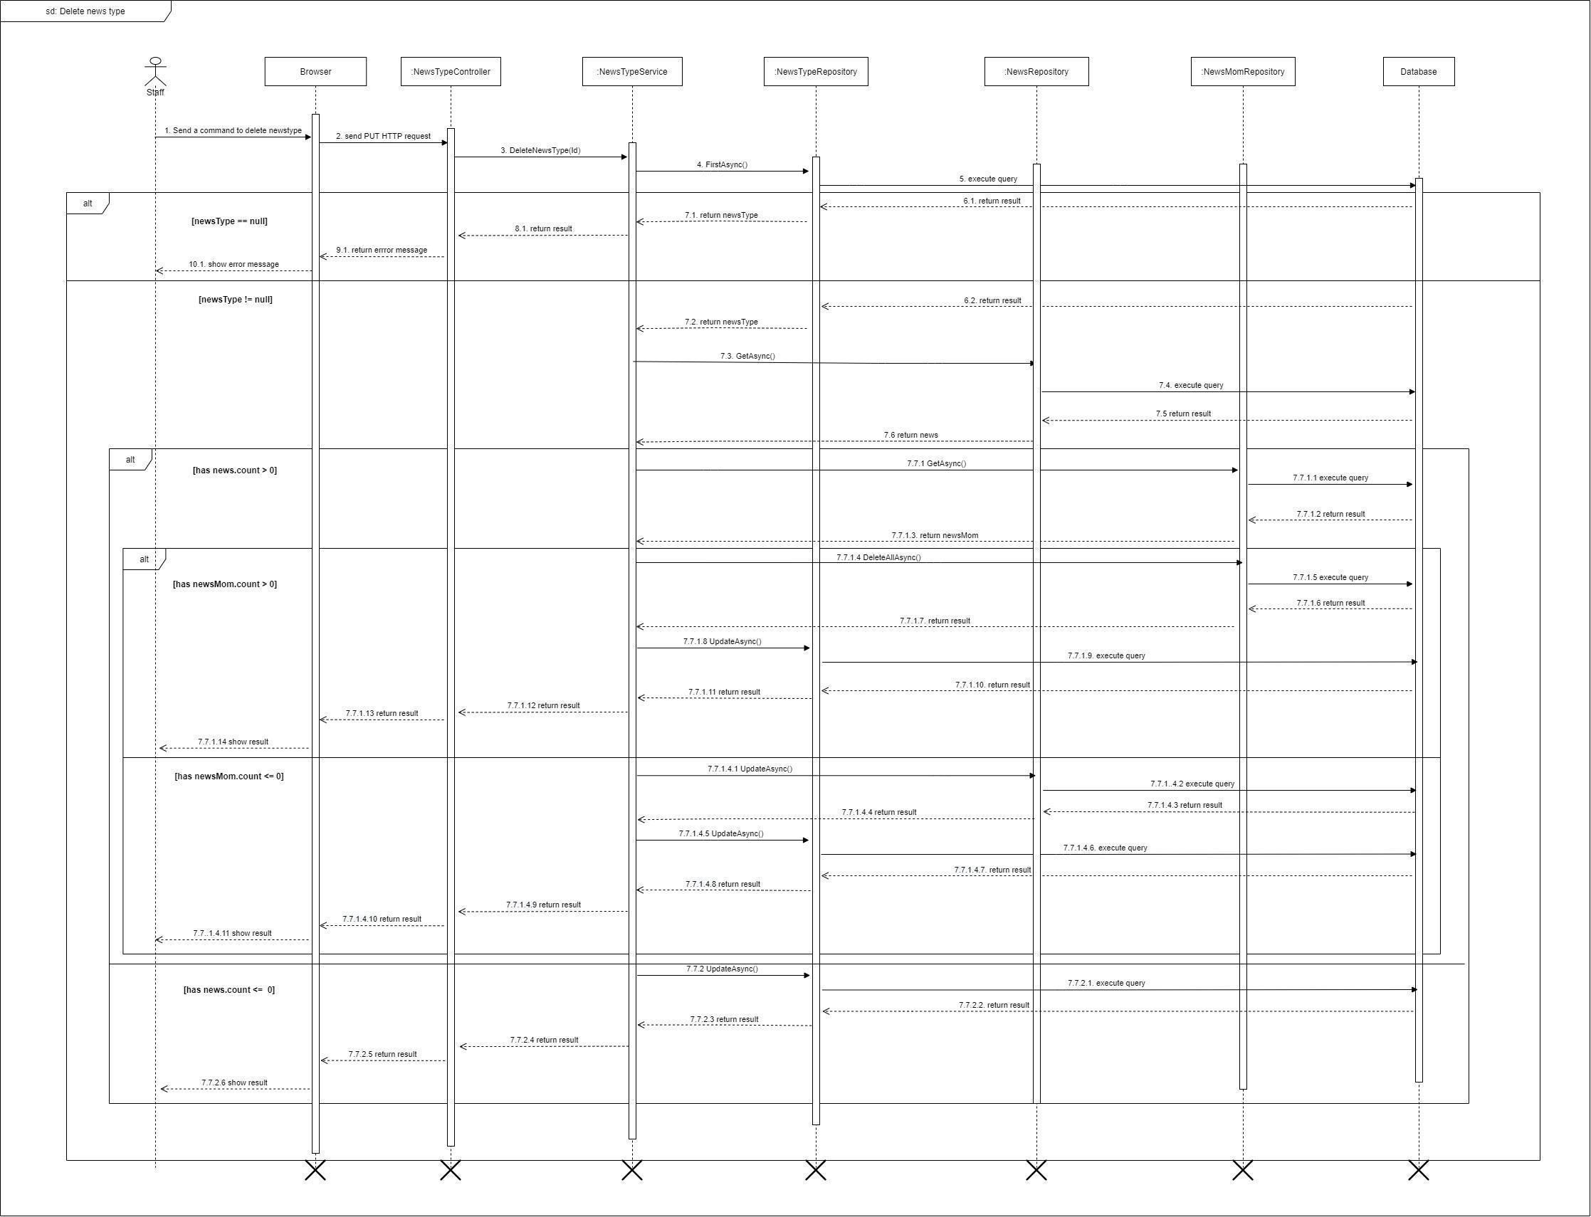

Figure 68 - <Sequence Diagram> Delete news type

#### 3.2.17. Approve post

***Summary:*** *This diagram shows the process for the actor to approve post.*

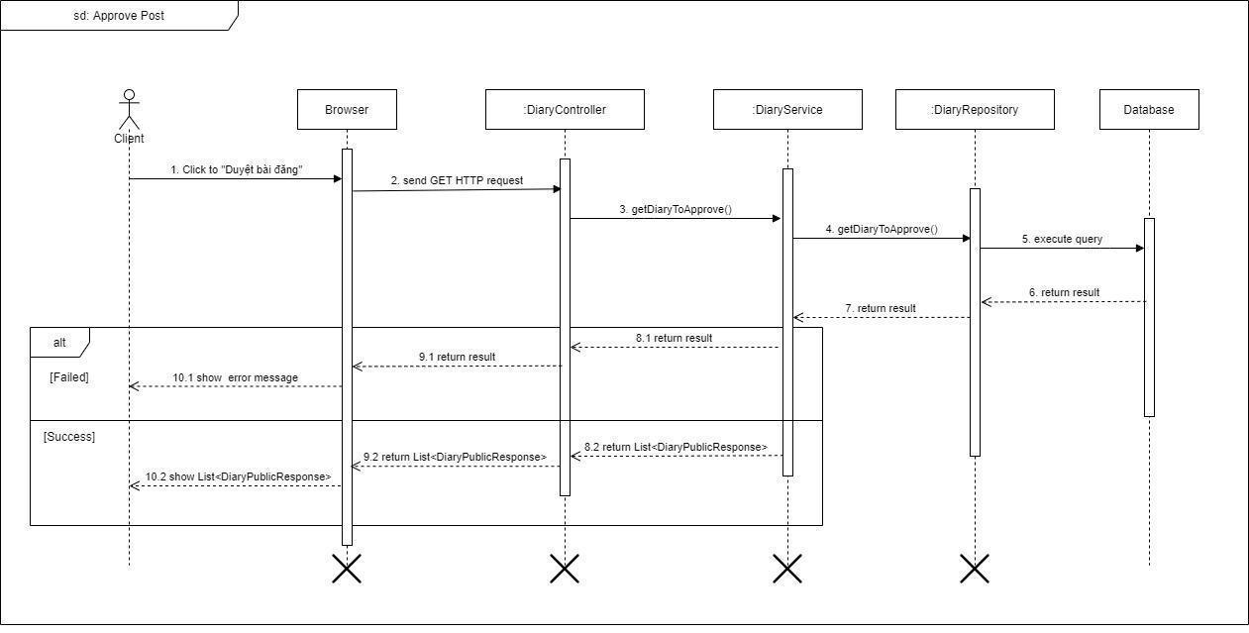

Figure 69 - <Sequence Diagram> Approve post

#### 3.2.18. Update diary

***Summary:*** *This diagram shows the process for the actor's update diary.*

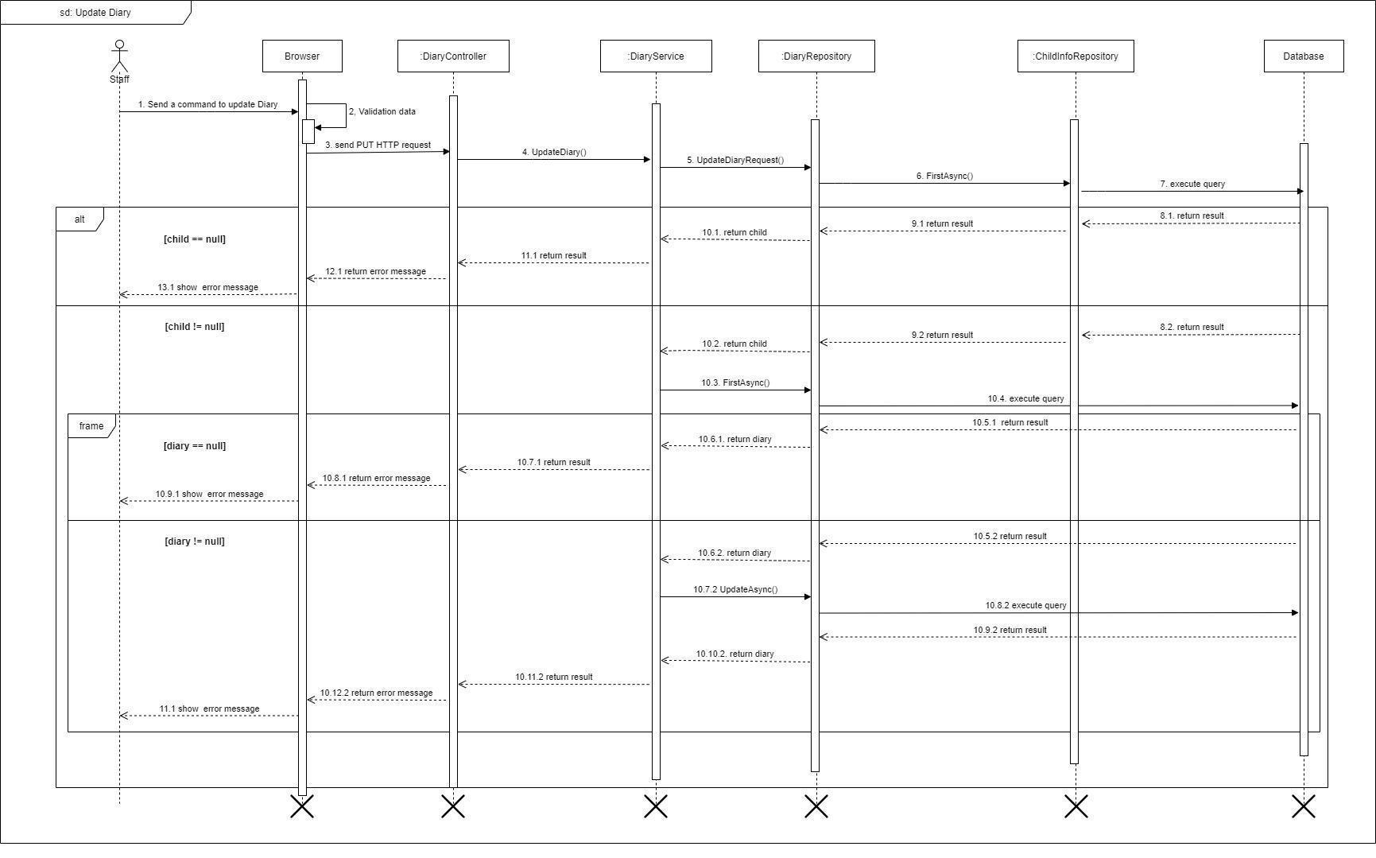

Figure 70 - <Sequence Diagram> Update diary

#### 3.2.19. Get profile

***Summary:*** *This diagram shows the process for the actor to get profile.*

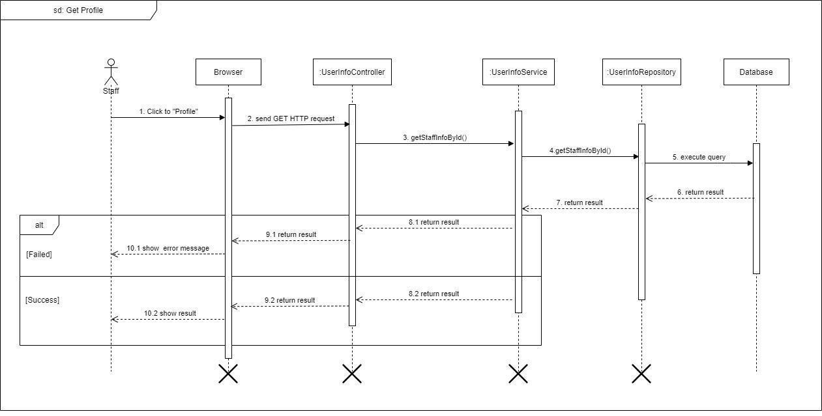

Figure 71 - <Sequence Diagram> Get profile

#### 3.2.20. Get all guidebook

***Summary:*** *This diagram shows the process for the actor to get all the guidebooks.*

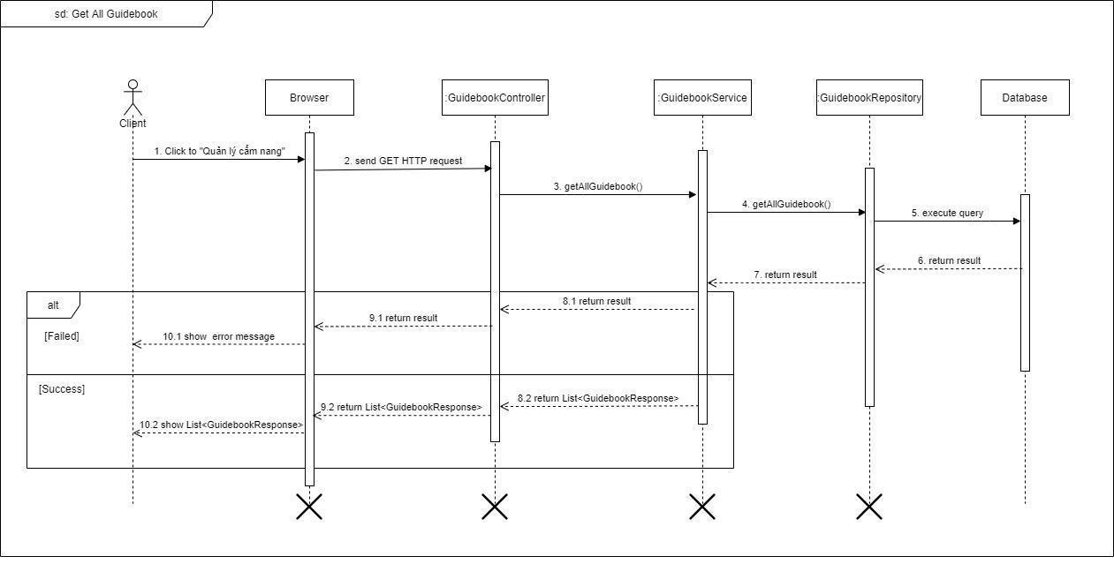

Figure 72 - <Sequence Diagram> Get all guidebook

#### 3.2.21. Get all guidebook type

***Summary:*** *This diagram shows the process for the actor to get all the guidebooks.*

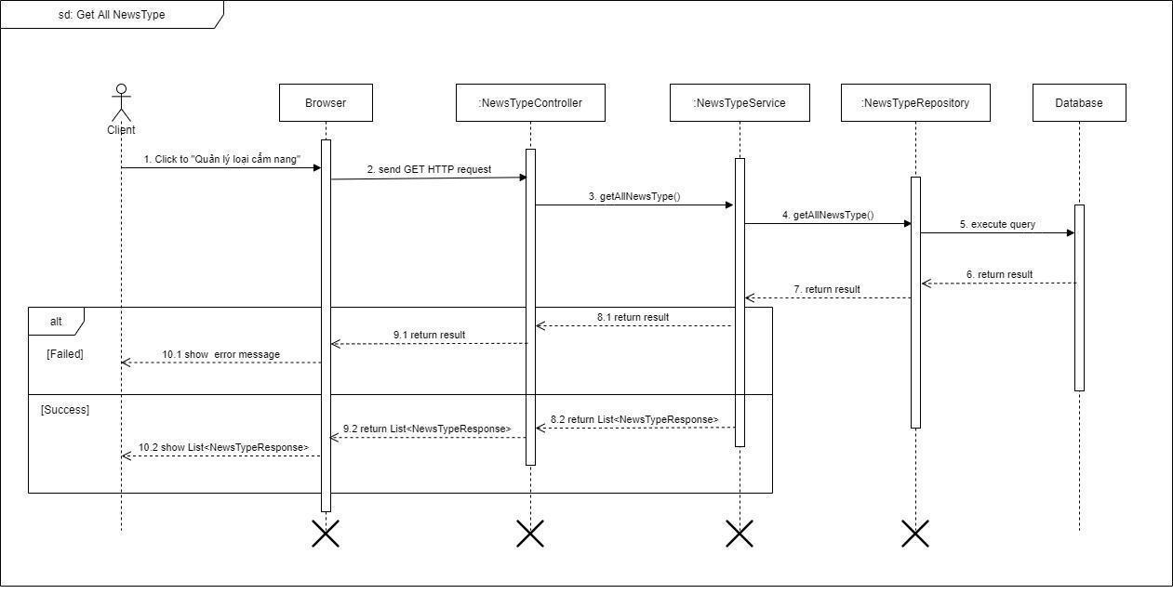

Figure 73 - <Sequence Diagram> Get all guidebook type

#### 3.2.22. Get all news type

***Summary:*** *This diagram shows the process for the actor to get all news type.*

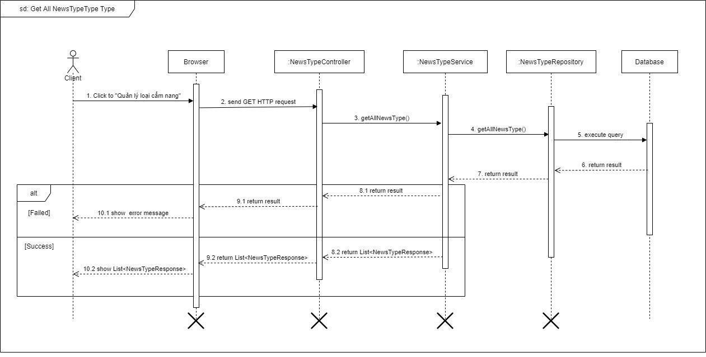

Figure 74 - <Sequence Diagram> Get all news type

### 3.3. Activity Diagram

### View news detail

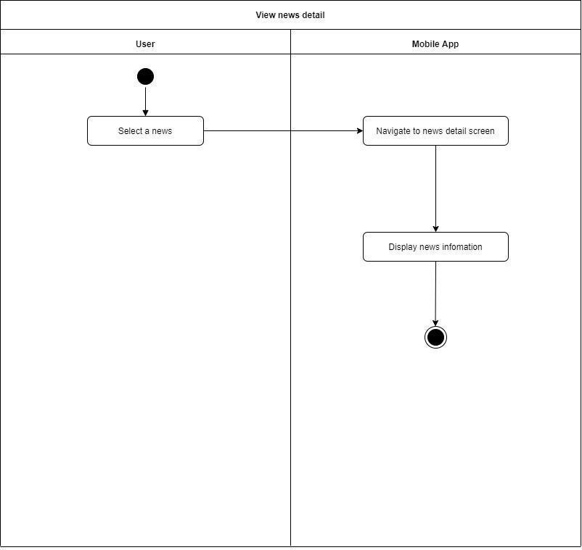

Figure 75 - <Activity Diagram> View news detail

### Add diary

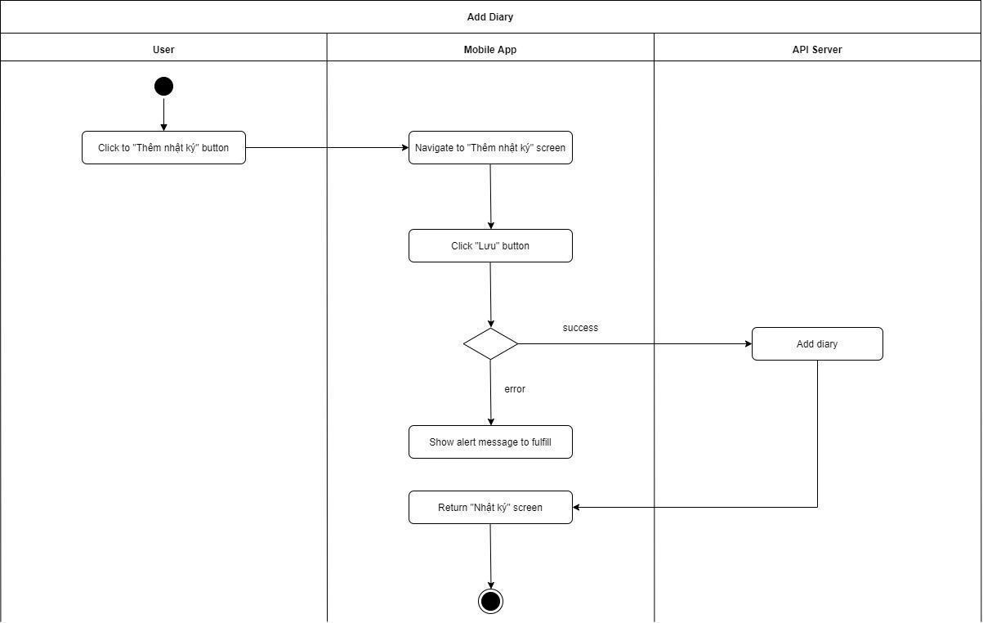

Figure 76 - <Activity Diagram> Add diary

### View diary detail

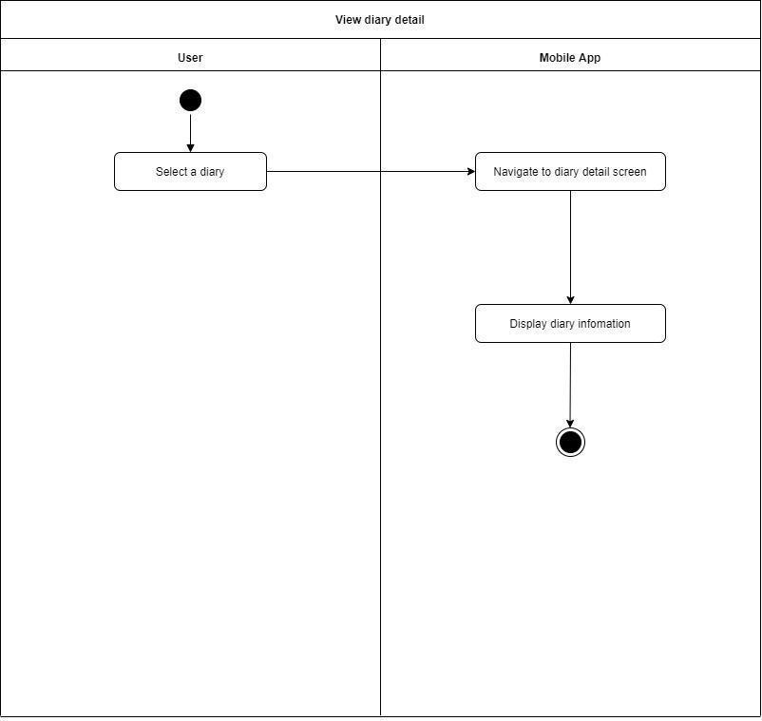

Figure 77 - <Activity Diagram> View diary detail

### Edit diary

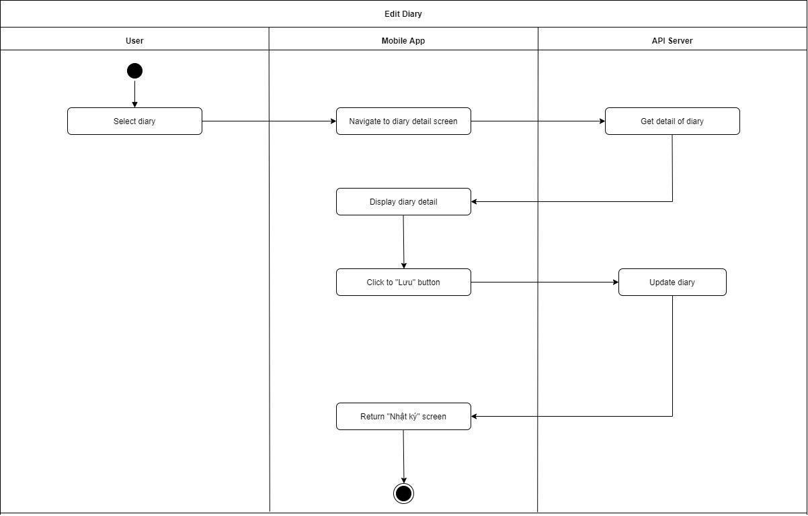

Figure 78 - <Activity Diagram> Edit diary

### View vaccine schedule

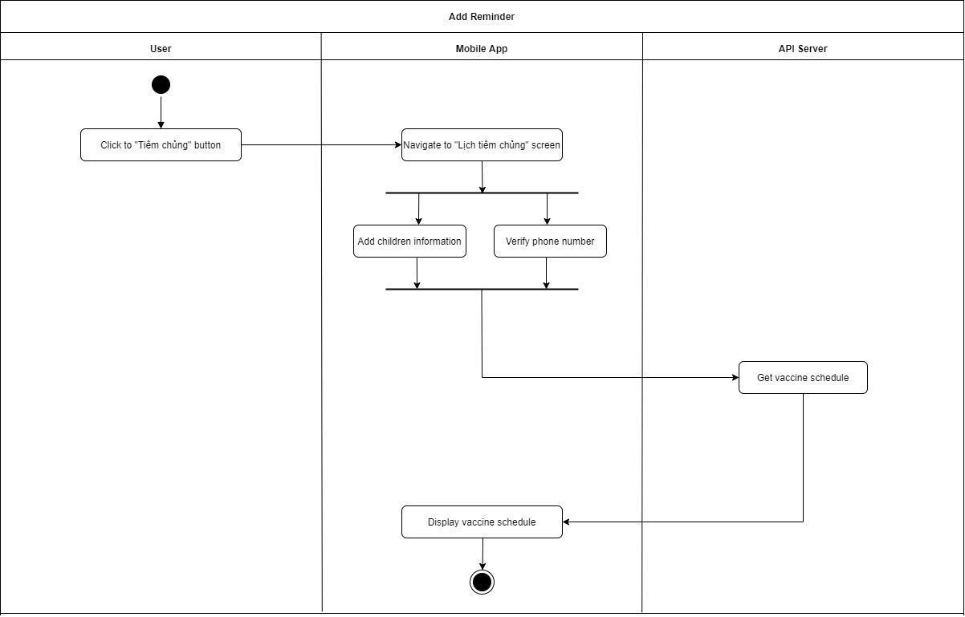

Figure 79 - <Activity Diagram> View vaccine schedule

### View vaccine schedule detail

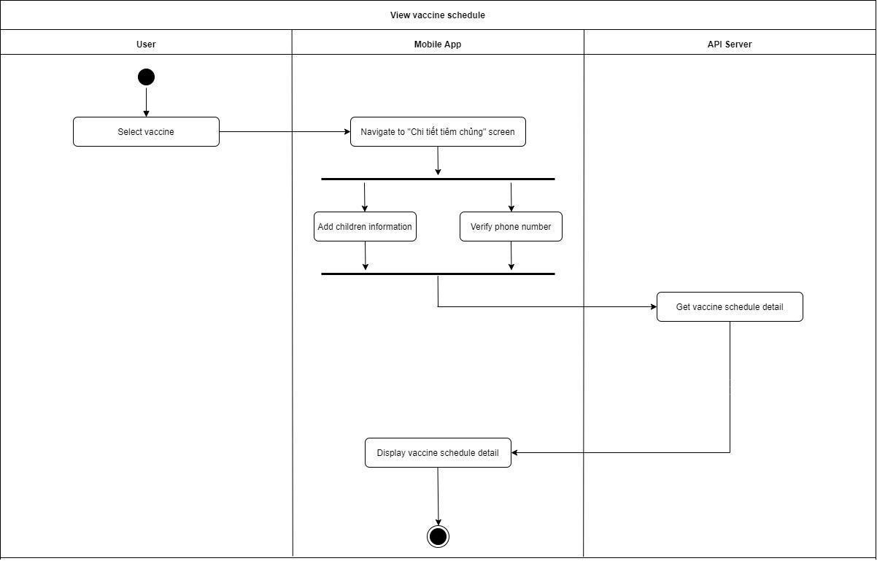

Figure 80 - <Activity Diagram> View vaccine schedule detail

### Add children information

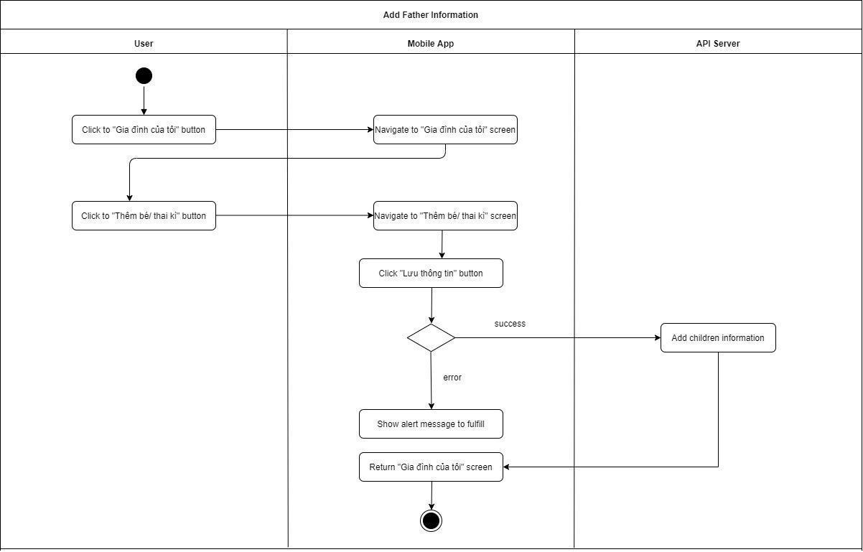

Figure 81 - <Activity Diagram> Add children information

### Add father information

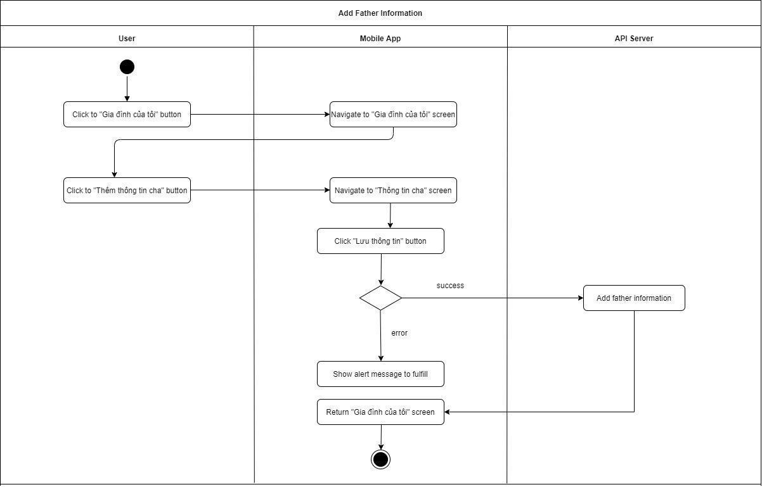

Figure 82 - <Activity Diagram> Add children information

### Public post to community

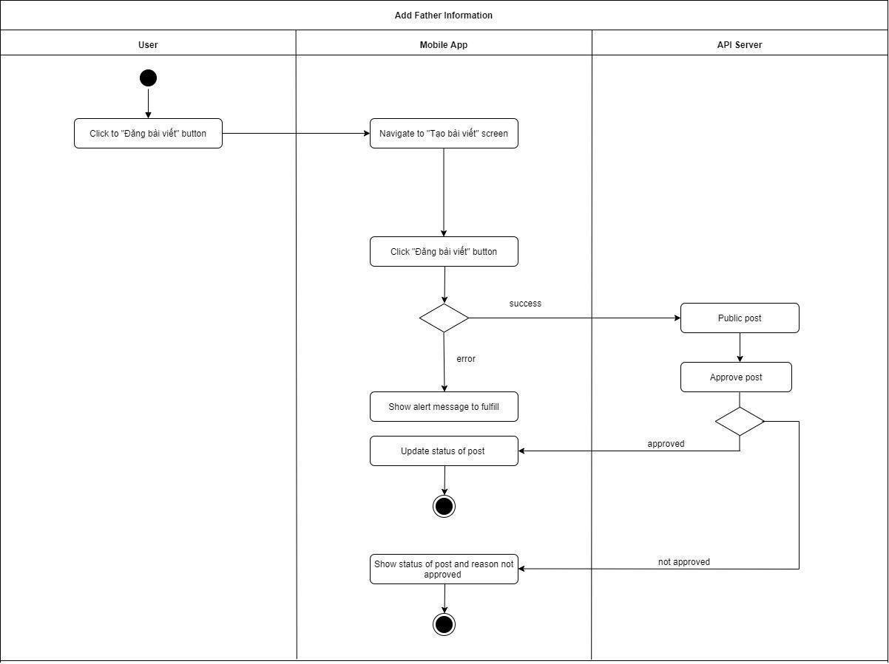

Figure 83 - <Activity Diagram> Public post to community

### Update teething process

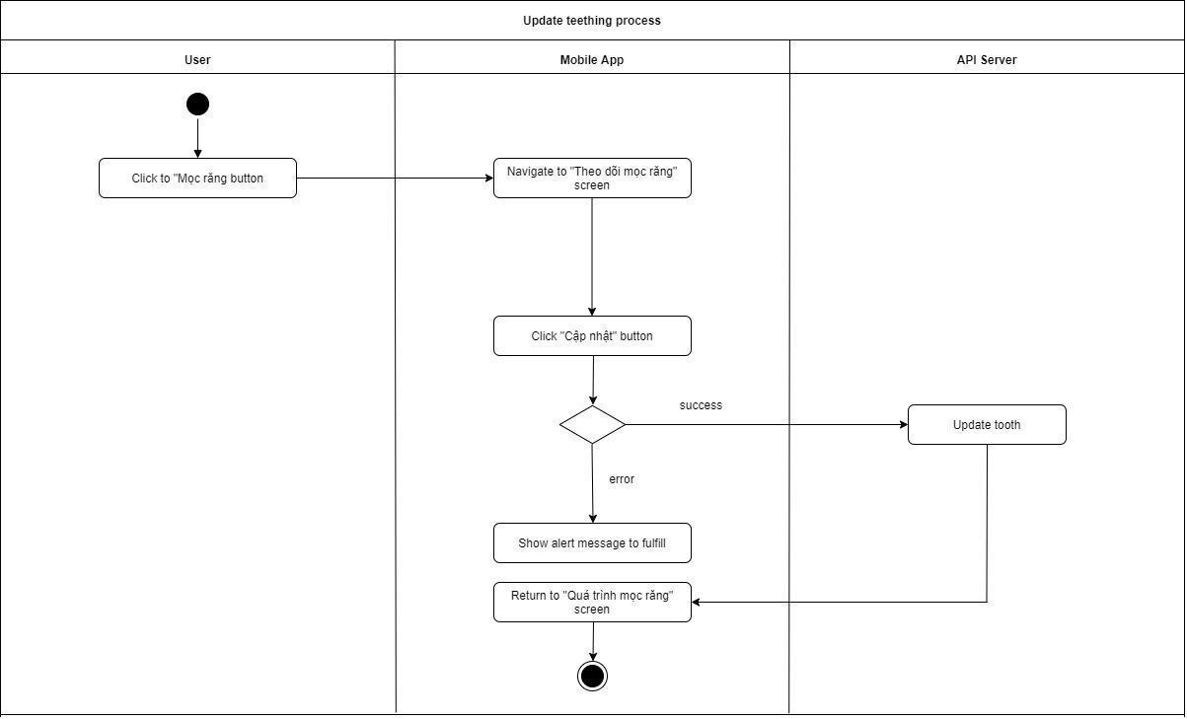

Figure 84 - <Activity Diagram> Update teething process

### View guidebook detail

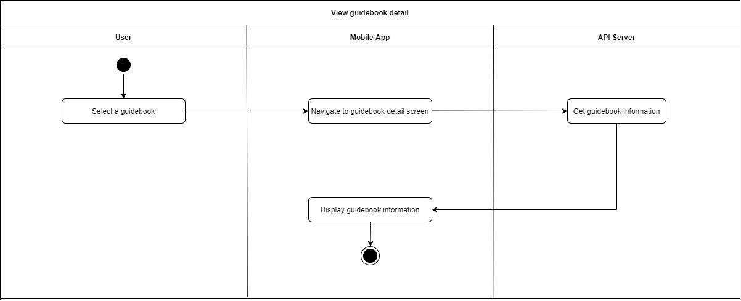

Figure 85 - <Activity Diagram> View guidebook detaill

### Update children information

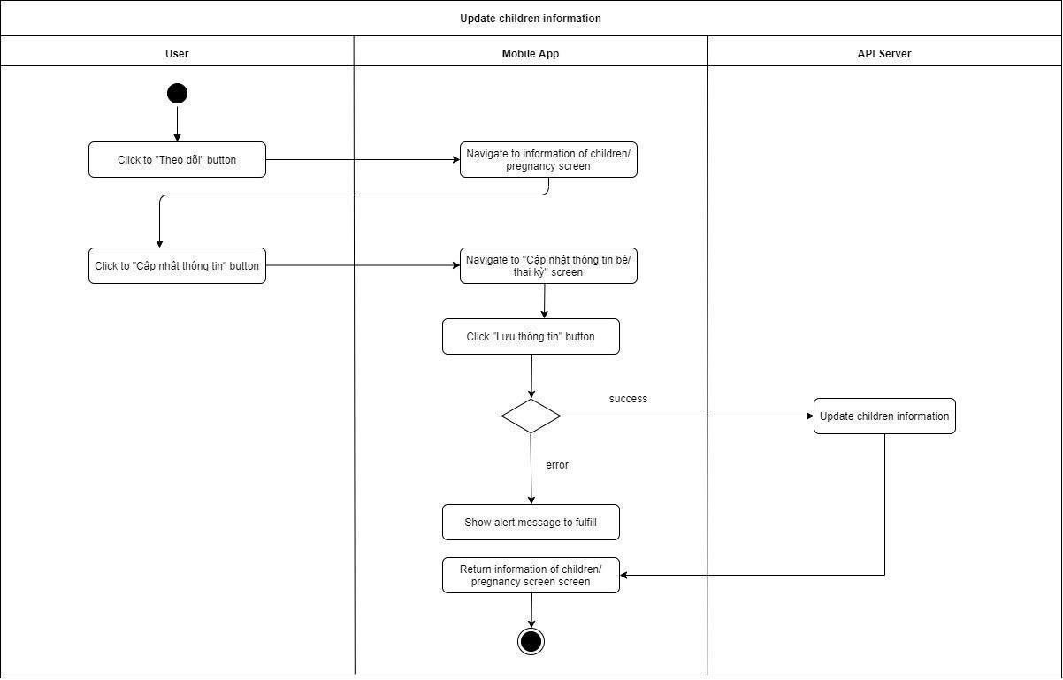

Figure 86 - <Activity Diagram> Update children information

## 4. Data & Database Design

### 4.1. Table Relationships

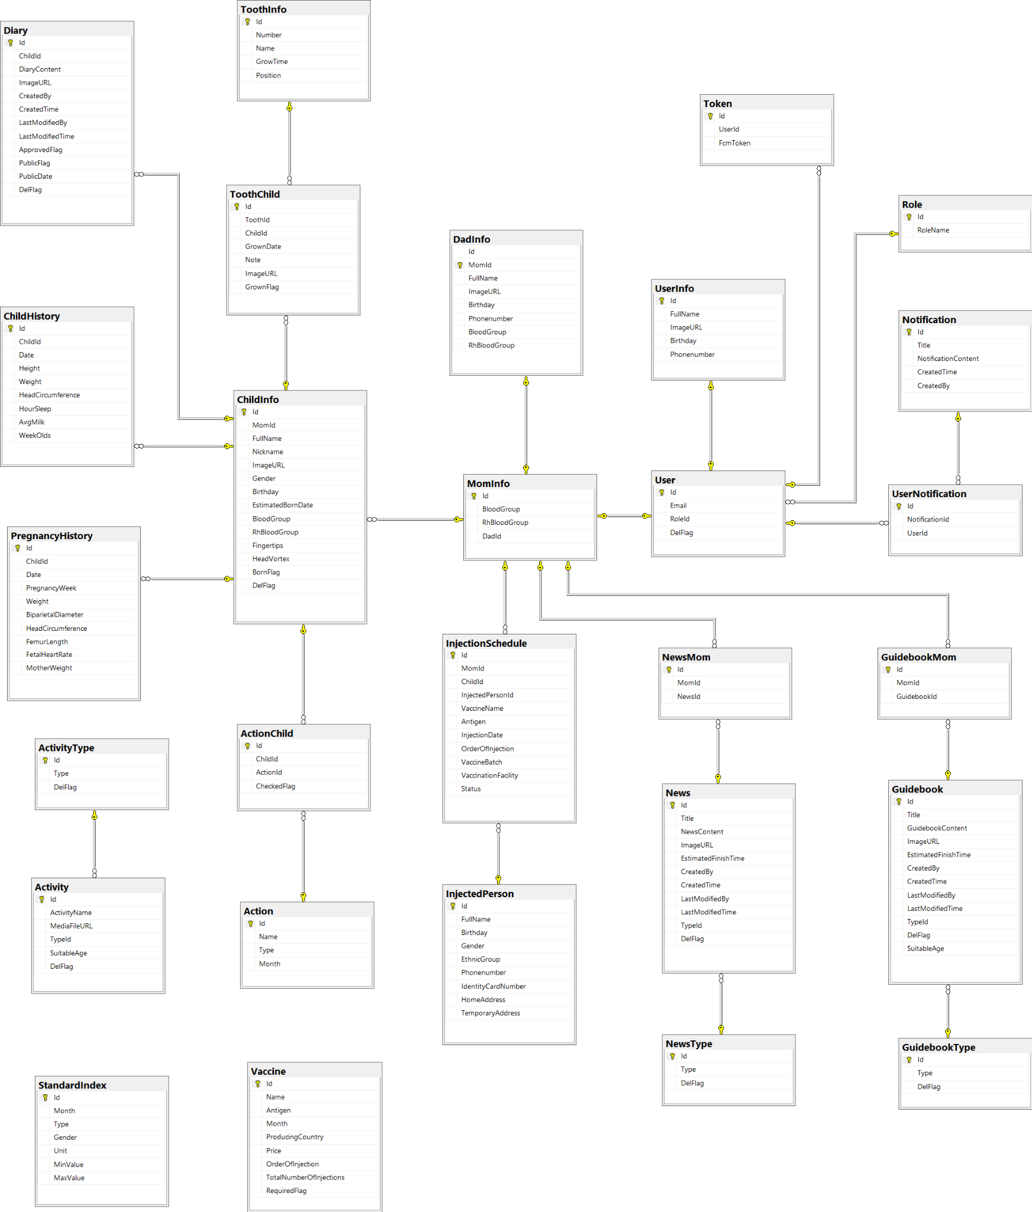

Figure 87 - Physical Diagram

### 4.2. Data dictionary

**UserInfo**

|  |  |  |  |  |  |  |
| --- | --- | --- | --- | --- | --- | --- |
| **Field name** | **Type** | **Size(bytes)** | **Unique** | **Not Null** | **PK/FK** | **Notes** |
| Id | varchar | 100 | Yes | Yes | PK | Unique identifier of user |
| FullName | nvarchar | 200 | No | Yes |  | The full name of user |
| ImageURL | varchar | max | No | No |  | The image of user |
| Birthday | varchar | 50 | No | No |  | The birthday of user |
| PhoneNumber | varchar | 10 | No | No |  | The phone number of user |

Table 85 - <Data dictionary> UserInfo

**MomInfo**

|  |  |  |  |  |  |  |
| --- | --- | --- | --- | --- | --- | --- |
| **Field name** | **Type** | **Size(bytes)** | **Unique** | **Not Null** | **PK/FK** | **Notes** |
| Id | varchar | 100 | Yes | Yes | PK | Unique identifier of mom |
| BloodGroup | varchar | 10 | No | No |  | The blood group of mom |
| RhBloodGroup | varchar | 10 | No | No |  | The rh blood group of mom |
| DadId | varchar | 50 | No | No |  | Unique identifier of dad |

Table 86 - <Data dictionary> MomInfo

**DadInfo**

|  |  |  |  |  |  |  |
| --- | --- | --- | --- | --- | --- | --- |
| **Field name** | **Type** | **Size(bytes)** | **Unique** | **Not Null** | **PK/FK** | **Notes** |
| Id | varchar | 50 | Yes | Yes | PK | Unique identifier of dad |
| MomId | varchar | 100 | No | Yes | FK | Unique identifier of mom |
| Phonenumber | varchar | 10 | No | No |  | The phone number of a father |
| BloodGroup | varchar | 10 | No | No |  | The blood group of a father |
| RhBloodGroup | varchar | 10 | No | No |  | The rh blood group of a father |
| Birthday | varchar | 50 | No | No |  | The birthday of a father |
| FullName | nvarchar | 200 | No | Yes |  | The full name of a dad |
| ImageURL | varchar | max | No | No |  | The image of a dad |

Table 87 - <Data dictionary> DadInfo

**News**

|  |  |  |  |  |  |  |
| --- | --- | --- | --- | --- | --- | --- |
| **Field name** | **Type** | **Size(bytes)** | **Unique** | **Not Null** | **PK/FK** | **Notes** |
| Id | varchar | 50 | Yes | Yes | PK | Unique identifier of a News |
| Title | nvarchar | 200 | No | Yes |  | The title of a news |
| ImageURL | varchar | max | No | No |  | The image of a news |
| NewsContent | nvarchar | max | No | Yes |  | The news content of a news |
| TypeId | int |  | No | No | FK | Unique identifier of type |
| EstimatedFinishTime | smallint |  | No | No |  | The estimated finish time of a news |
| CreatedBy | nvarchar | 100 | No | No |  | The estimated finish time of a news |
| CreatedTime | datetime |  | No | No |  | The estimated finish time of a news |
| LastModifiedBy | nvarchar | 100 | No | No |  | The user last modified of a news |
| LastModifiedTime | datetime |  | No | No |  | The last modified time of a news |
| DelFlag | bit |  | No | Yes |  | The status delete of news |

Table 88 - <Data dictionary> News

**Token**

|  |  |  |  |  |  |  |
| --- | --- | --- | --- | --- | --- | --- |
| **Field name** | **Type** | **Size(bytes)** | **Unique** | **Not Null** | **PK/FK** | **Notes** |
| Id | int |  | Yes | Yes | PK | Unique identifier of token |
| UserId | varchar | 100 | No | Yes | FK | Unique identifier of a User |
| FcmToken | varchar | max | No | Yes |  | The fcm token of a token |

Table 89 - <Data dictionary> Token

**Injection Schedule**

|  |  |  |  |  |  |  |
| --- | --- | --- | --- | --- | --- | --- |
| **Field name** | **Type** | **Size(bytes)** | **Unique** | **Not Null** | **PK/FK** | **Notes** |
| Id | float |  | Yes | Yes | PK | Unique identifier of a Injection Schedule |
| MomId | varchar | 100 | No | No |  | Unique identifier of a mom |
| InjectedPersonId | float |  | No | No |  | Unique identifier of a injected person |
| VaccineName | nvarchar | 100 | No | No |  | The vaccine name of a vaccine in injection schedule |
| Antigen | nvarchar | 50 | No | No | FK | The antigen of a vaccine in injection schedule |
| InjectionDate | varchar | 50 | No | No |  | The injection date of a vaccine in injection schedule |
| OrderOfInjection | tinyint |  | No | No |  | The order of injection of a vaccine in injection schedule |
| VaccineBatch | varchar | 30 | No | No |  | The vaccine batch of a vaccine in injection schedule |
| VaccineFacility | nvarchar | 100 | No | No |  | The vaccine facility of a vaccine in injection schedule |
| Status | tinyint |  | No | Yes |  | The status of a vaccine in injection schedule |

Table 90 - <Data dictionary> Injection Schedule

**NewsType**

|  |  |  |  |  |  |  |
| --- | --- | --- | --- | --- | --- | --- |
| **Field name** | **Type** | **Size(bytes)** | **Unique** | **Not Null** | **PK/FK** | **Notes** |
| Id | int |  | Yes | Yes | PK | Unique identifier of a news type |
| Type | nvarchar | 100 | No | Yes |  | The type of a news type |
| DelFlag | bit |  | No | Yes |  | The status delete of a news type |

Table 91 - <Data dictionary> NewsType

**Role**

|  |  |  |  |  |  |  |
| --- | --- | --- | --- | --- | --- | --- |
| **Field name** | **Type** | **Size(bytes)** | **Unique** | **Not Null** | **PK/FK** | **Notes** |
| Id | int |  | Yes | Yes | PK | Unique identifier of a Role |
| RoleName | nvarchar | 100 | No | Yes |  | The name of a Role |

Table 92 - <Data dictionary> Role

**ChildInfo**

|  |  |  |  |  |  |  |
| --- | --- | --- | --- | --- | --- | --- |
| **Field name** | **Type** | **Size(bytes)** | **Unique** | **Not Null** | **PK/FK** | **Notes** |
| Gender | tinyint |  | No | No |  | The gender of a child |
| Fingertips | tinyint |  | No | No |  | The fingertips of a child |
| HeadVortex | tinyint |  | No | No |  | The head vortex of a child |
| BloodGroup | nvarchar | 10 | No | No |  | The blood group of a child |
| RhBloodGroup | nvarchar | 10 | No | No |  | The rh blood group of a child |
| FullName | nvarchar | 200 | No | Yes |  | The full name of a child |
| NickName | nvarchar | 200 | No | No |  | The nickname of a child |
| ImageURL | varchar | max | No | No |  | The image of a child |
| Birthday | nvarchar | 50 | No | No |  | The birthday of a child |
| Id | varchar | 50 | No | Yes | PK | Unique identifier of a child |
| MomId | varchar | 100 | No | Yes | FK | Unique identifier of a mom |
| EstimatedBornDate | varchar | 50 | No | No |  | The estimated born date of a child |
| BornFlag | bit |  | No | Yes |  | The status born of child |
| DelFlag | bit |  | No | Yes |  | The status delete of child |

Table 93 - <Data dictionary> ChildInfo

**Diary**

|  |  |  |  |  |  |  |
| --- | --- | --- | --- | --- | --- | --- |
| **Field name** | **Type** | **Size(bytes)** | **Unique** | **Not Null** | **PK/FK** | **Notes** |
| Id | int |  | Yes | Yes | PK | Unique identifier of a diary |
| DiaryContent | nvarchar | max | No | Yes |  | The content of a diary |
| ImageURL | varchar | max | No | No |  | The image of a diary |
| ApprovedFlag | bit |  | No | Yes |  | The status approved of diary |
| ChildId | varchar | 50 | No | Yes | FK | Unique identifier of a child |
| PublicFlag | bit |  | No | Yes |  | The status public of diary |
| CreatedBy | nvarchar | 100 | No | No |  | The estimated finish time of a diary |
| CreatedTime | datetime |  | No | No |  | The estimated finish time of a diary |
| LastModifiedBy | nvarchar | 100 | No | No |  | The user last modified of a diary |
| LastModifiedTime | datetime |  | No | No |  | The last modified time of a diary |
| DelFlag | bit |  | No | Yes |  | The status delete of diary |
| PublicDate | datetime |  | No | No |  | The public date of diary |

Table 94 - <Data dictionary> Diary

**PregnancyHistory**

|  |  |  |  |  |  |  |
| --- | --- | --- | --- | --- | --- | --- |
| **Field name** | **Type** | **Size(bytes)** | **Unique** | **Not Null** | **PK/FK** | **Notes** |
| Id | int |  | Yes | Yes | PK | Unique identifier of a pregnancy history |
| ChildId | varchar | 50 | No | Yes | FK | Unique identifier of a child |
| HeadCircumference | float | max | No | No |  | The head circumference of a pregnancy in pregnancy history |
| FemurLength | float |  | No | No |  | The femur length of a pregnancy in pregnancy history |
| FetalHeartRate | varchar | 50 | No | No |  | The fetal heart rate of a pregnancy in pregnancy history |
| PregnancyWeek | smallint |  | No | No |  | The week of a pregnancy in pregnancy history |
| Weight | float |  | No | No |  | The weight of a pregnancy in pregnancy history |
| PregnancyType | float |  | No | No |  | The type a pregnancy |
| Date | varchar | 50 | No | Yes |  | The date of a pregnancy in pregnancy history |
| BiparietalDiameter | float |  | No | No |  | The biparietal diameter of a pregnancy in pregnancy history |
| MotherWeight | float |  | No | No |  | The mother weight of a pregnancy in pregnancy history |

Table 95 - <Data dictionary> PregnancyHistory

**Activity**

|  |  |  |  |  |  |  |
| --- | --- | --- | --- | --- | --- | --- |
| **Field name** | **Type** | **Size(bytes)** | **Unique** | **Not Null** | **PK/FK** | **Notes** |
| Id | Integer |  | Yes | Yes | PK | Unique identifier of a activity |
| ActivityName | nvarchar | 200 | No | No |  | Unique identifier of a child |
| MediaFileURL | varchar | max | No | No |  | The media file of a activity |
| SuitableAge | tinyint |  | No | No |  | The suitable age of a activity |
| TypeId | int |  | No | Yes | FK | Unique identifier of a type |
| DelFlag | bit |  | No | Yes |  | The status delete of activity |

Table 96 - <Data dictionary> Activity

**Vaccine**

|  |  |  |  |  |  |  |
| --- | --- | --- | --- | --- | --- | --- |
| **Field name** | **Type** | **Size(bytes)** | **Unique** | **Not Null** | **PK/FK** | **Notes** |
| Id | int |  | Yes | Yes | PK | Unique identifier of a vaccine |
| Name | nvarchar | 200 | No | No |  | The name of a vaccine |
| TotalNumberOfInjections | tinyint |  | No | No |  | The total number of injections of a vaccine |
| Price | float |  | No | No |  | The price of a vaccine |
| ProducingCountry | nvarchar | 100 | No | No |  | The producing country of a vaccine |
| Antigen | nvarchar | 50 | No | No |  | The antigen of a vaccine |
| Month | tinyint |  | No | No |  | The month of a vaccine |
| RequiredFlag | bit |  | No | No |  | The status required of a vaccine |
| OrderOfInjection | tinyint |  | No | No |  | The order of injection of a vaccine |

Table 97 - <Data dictionary> Vaccine

**ChildHistory**

|  |  |  |  |  |  |  |
| --- | --- | --- | --- | --- | --- | --- |
| **Field name** | **Type** | **Size(bytes)** | **Unique** | **Not Null** | **PK/FK** | **Notes** |
| Id | int |  | Yes | Yes | PK | Unique identifier of a child history |
| ChildId | varchar | 50 | No | Yes | FK | Unique identifier of a child |
| HeadCircumference | float |  | No | No |  | The head circumference of a child in child history |
| HourSleep | float |  | No | No |  | The hour sleep of a child in child history |
| AvgMilk | float |  | No | No |  | The average milk of a child in child history |
| WeekOlds | tinyint |  | No | No |  | The week old of a child in child history |
| Weight | float |  | No | No |  | The weight of a child in child history |
| Date | varchar | 50 | No | No |  | The date of a pregnancy in pregnancy history |
| Height | float |  | No | No |  | The height of a child in child history |

Table 98 - <Data dictionary> Vaccine History

**GuidebookType**

|  |  |  |  |  |  |  |
| --- | --- | --- | --- | --- | --- | --- |
| **Field name** | **Type** | **Size(bytes)** | **Unique** | **Not Null** | **PK/FK** | **Notes** |
| Id | int |  | Yes | Yes | PK | Unique identifier of a child history |
| Type | nvarchar | 100 | No | Yes |  | Unique identifier of a child |
| DelFlag | bit |  | No | Yes |  | The head circumference of a child in child history |

Table 99 - <Data dictionary> GuidebookType

**ActivityType**

|  |  |  |  |  |  |  |
| --- | --- | --- | --- | --- | --- | --- |
| **Field name** | **Type** | **Size(bytes)** | **Unique** | **Not Null** | **PK/FK** | **Notes** |
| Id | int |  | Yes | Yes | PK | Unique identifier of a activity type |
| Type | nvarchar | 100 | No | Yes |  | The type of a activity type |
| DelFlag | bit |  | No | Yes |  | The status delete of a activity type |

Table 100 - <Data dictionary> ActivityType

**GuidebookMom**

|  |  |  |  |  |  |  |
| --- | --- | --- | --- | --- | --- | --- |
| **Field name** | **Type** | **Size(bytes)** | **Unique** | **Not Null** | **PK/FK** | **Notes** |
| Id | int |  | Yes | Yes | PK | Unique identifier of a activity type |
| MomId | varchar | 50 | No | Yes | FK | The type of a activity type |
| GuidebookId | varchar | 50 | No | Yes | FK | The status delete of a activity type |

Table 101 - <Data dictionary> GuidebookMom

**NewsMom**

|  |  |  |  |  |  |  |
| --- | --- | --- | --- | --- | --- | --- |
| **Field name** | **Type** | **Size(bytes)** | **Unique** | **Not Null** | **PK/FK** | **Notes** |
| Id | int |  | Yes | Yes | PK | Unique identifier of a news mom |
| MomId | varchar | 50 | No | Yes | FK | Unique identifier of a mom |
| NewsId | varchar | 50 | No | Yes | FK | Unique identifier of a news |

Table 102 - <Data dictionary> NewsMom

**Guidebook**

|  |  |  |  |  |  |  |
| --- | --- | --- | --- | --- | --- | --- |
| **Field name** | **Type** | **Size(bytes)** | **Unique** | **Not Null** | **PK/FK** | **Notes** |
| Id | int |  | Yes | Yes | PK | Unique identifier of a guidebook |
| Title | nvarchar | 100 | No | Yes |  | The title of a guidebook |
| ImageURL | nvarchar | max | No | No |  | The image of a guidebook |
| GuidebookContent | nvarchar | 200 | No | Yes |  | The news content of a guidebook |
| TypeID | int |  | No | Yes | FK | Unique identifier of type |
| EstimatedFinishTime | tinyint |  | No | No |  | The estimated finish time of a guidebook |
| CreatedBy | nvarchar | 100 | No | No |  | The estimated finish time of a guidebook |
| CreatedTime | dateTime |  | No | No |  | The estimated finish time of a guidebook |
| LastModifiedBy | nvarchar | 100 | No | No |  | The user last modified of a guidebook |
| LastModifiedTime | dateTime |  | No | No |  | The last modified time of a guidebook |
| DelFlag | bit |  | No | Yes |  | The status delete of guidebook |
| SuitableAge | tinyint |  | No | No |  | The suitable age of a guidebook |

Table 103 - <Data dictionary> Guidebook

**User**

|  |  |  |  |  |  |  |
| --- | --- | --- | --- | --- | --- | --- |
| **Field name** | **Type** | **Size(bytes)** | **Unique** | **Not Null** | **PK/FK** | **Notes** |
| Id | varchar | 100 | Yes | Yes | PK | Unique identifier of user |
| Email | varchar | 100 | No | Yes |  | The email of user |
| RoleId | varchar | 10 | No | Yes | FK | Unique identifier of role |
| DelFlag | bit |  | No | Yes |  | The status delete of user |

Table 104 - <Data dictionary> User

**UserNotification**

|  |  |  |  |  |  |  |
| --- | --- | --- | --- | --- | --- | --- |
| **Field name** | **Type** | **Size(bytes)** | **Unique** | **Not Null** | **PK/FK** | **Notes** |
| Id | int |  | Yes | Yes | PK | Unique identifier of user notification |
| NotificationId | int |  | No | Yes | FK | Unique identifier of notification |
| UserId | varchar | 50 | No | Yes | FK | Unique identifier of user notification |

Table 105 - <Data dictionary> UserNotification

**Notification**

|  |  |  |  |  |  |  |
| --- | --- | --- | --- | --- | --- | --- |
| **Field name** | **Type** | **Size(bytes)** | **Unique** | **Not Null** | **PK/FK** | **Notes** |
| Id | varchar | 50 | Yes | Yes | PK | Unique identifier of notification |
| Title | tinyint |  | No | Yes |  | The title of notification |
| NotificationContent | nvarchar | 200 | No | Yes |  | The notification content of notification |
| CreatedBy | nvarchar | 50 | No | Yes |  | The estimated finish time of a notification |
| CreatedTime | tinyint |  | No | Yes |  | The estimated finish time of a notification |

Table 106 - <Data dictionary> Notification

**InjectedPerson Table**

|  |  |  |  |  |  |  |
| --- | --- | --- | --- | --- | --- | --- |
| **Field name** | **Type** | **Size(bytes)** | **Unique** | **Not Null** | **PK/FK** | **Notes** |
| Id | float |  | Yes | Yes | PK | Unique identifier of injected person |
| Gender | tinyint |  | No | No |  | The gender of a person in injected person |
| Phonenumber | varchar | 10 | No | No |  | The phone number of a person in injected person |
| EthnicGroup | nvarchar | 20 | No | No |  | The ethnic group of a person in injected person |
| IdentityCardNumber | varchar | 12 | No | No |  | The identity card number of a person in injected person |
| Birthday | varchar | 50 | No | No |  | The birthday of a person in injected person |
| FullName | nvarchar | 200 | No | Yes |  | The fullname of a person in injected person |
| HomeAddress | nvarchar | 250 | No | No |  | The home address of a person in injected person |
| TemporaryAddress | nvarchar | 250 | No | No |  | The temporary address of a person in injected person |

Table 107 - <Data dictionary> InjectedPerson

**StandardIndex**

|  |  |  |  |  |  |  |
| --- | --- | --- | --- | --- | --- | --- |
| **Field name** | **Type** | **Size(bytes)** | **Unique** | **Not Null** | **PK/FK** | **Notes** |
| Id | int |  | Yes | Yes | PK | Unique identifier of standard index |
| Month | smallint |  | No | Yes |  | The month of standard index |
| Type | varchar | 20 | No | Yes |  | The type of standard index |
| Gender | tinyint |  | No | Yes |  | The gender of standard index |
| Unit | varchar | 10 | No | Yes |  | The unit of standard index |
| MinValue | Float |  |  | Yes |  | The min value of standard index |
| MaxValue | float |  |  | Yes |  | The max value of standard index |

Table 108 - <Data dictionary> Standard Index

**ToothInfo**

|  |  |  |  |  |  |  |
| --- | --- | --- | --- | --- | --- | --- |
| **Field name** | **Type** | **Size(bytes)** | **Unique** | **Not Null** | **PK/FK** | **Notes** |
| Id | varchar | 50 | Yes | Yes | PK | Unique identifier of tooth info |
| Number | tinyint |  | No | Yes |  | The number of tooth info |
| GrowTime | nvarchar | 200 | No | Yes |  | The grow time of tooth info |
| Name | nvarchar | 50 | No | Yes |  | The name of tooth info |
| Position | tinyint |  | No | Yes |  | The position of tooth info |

Table 109 - <Data dictionary> ToothInfo

**Tooth**

|  |  |  |  |  |  |  |
| --- | --- | --- | --- | --- | --- | --- |
| **Field name** | **Type** | **Size(bytes)** | **Unique** | **Not Null** | **PK/FK** | **Notes** |
| Id | int |  | Yes | Yes | PK | Unique identifier of tooth |
| ToothId | varchar | 50 | No | Yes | FK | Unique identifier of tooth |
| ChildId | varchar | 50 | No | Yes | FK | Unique identifier of child |
| GrownDate | datetime |  | No | No |  | The grown date of tooth |
| Note | nvarchar | max | No | No |  | The note of tooth |
| ImageURL | varchar | max | No | No |  | The image of tooth |
| GrownFlag | bit |  | No | Yes |  | The status grown of tooth |

Table 110 - <Data dictionary> Tooth